Last weekend, a young school boy harassed by a ghost .Recent, strange incidents have left people curious.
THE GHOST OF THOMAS KEMPE
I interviewed the boy at the centre of all the mysterious. James the 12-year-old boy, said that there was a ghost in is house. The young Mr Harrison claimed that his house was becoming difficult to live in: there is something else in it. He told me all about the messages on the windows in bright red lipstick. The house was getting disrupted and verse’s smashed.
James dog has been barking strangely and thinks it is the ghost of Thomas Kempe is very mischievous and nuisance. “Why is the ghost in my house and why me?” James mum. Also known as Mrs Harrison. She also told me that her family is new to the village and everyone has made them feel welcome. James mum explained, James has been acting strange about the ghost I think he is just playing. “My sons room is always looking like a tip,” said Mrs Harrison.
“I’m not surprised he thinks there is a ghost in his room.” He says that he gets the blame for everything and says it’s his big sister that gets him in trouble. I still believe his sister. Mrs Harrison gave me more information about James, she went on about the dog and how it is barking into space. Yesterday I caught up with the hunter himself Bert Ellison. He said he was a builder and has caught a couple of ghosts in his life time. Bert explained “I don’t know if I can catch this ghost: It seems to be serious!”
If you catch the ghost or hear anything else call 019187532.

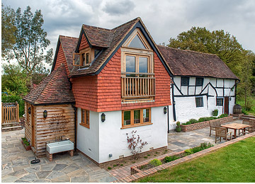
East End Cottage

