The Single Ghost!
In Ledsham, there is apparently a ghost lurking around a house. A young boy believes it really is a ghost. Or is it?
Today, we interviewed a young boy named James who told us what has been happening: he wants people to believe him. He said that old-fashioned notes have been going around the house non-stop. Also things have been falling off shelves; James has an idea to exorcise it. While it seems there is a ghost, the young boy will try to catch it.
After we interviewed the boy we asked his mam a few questions about the ghost. Mrs Harrison, the mam, told us he was going crazy about the poltergeist. We also asked her do you believe in ghosts. She said,

“No what silly person would believe in ghosts.”
At the end of today, we interviewed a decorator and builder, Bert Ellison. He says he’s also a ghost catcher trying to help James, the schoolboy. “This young boy says he’s sick of the ghost so I want to help.” he explained.
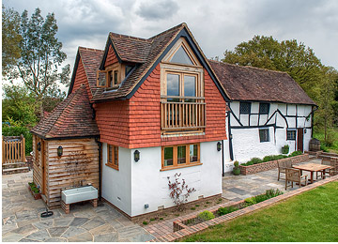
(Ledsham cottage.)
Today, these people really want the ghost to stay away from them because the young boy is having lots of ideas.

