GHOST OR TRICK
A young Mr Harrison has spotted a ghost. None of him family or friend believed him .I mean would you? This is set at East End Cottage.
The dog is barking for no reason at all. Things are being smashed and broken. Weird notes are being left behind it is really scary. James said he feels targeted but why has it got to be him .They have got a ghost catcher. I wish it would all go. He is getting all the blame for it.
James mam thinks James is going crazy. I am sick of him lying to me. The whole family think he is annoying too. We have just moved here everyone is friendly here.
Burt is next he is a builder and a decorator, but people say he is a ghost catcher too. People say James is crazy he is a little boy who has a ghost in his house. I have caught many ghosts. We had a plan how we could get the ghost.
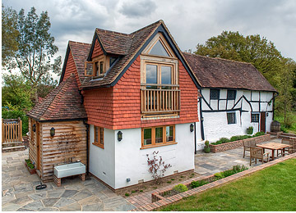
East end cottage

