GHOST OR A TRICK

The ghost of Lensham strikes again, at East End Cottage, after a little boy tries to get it to leave, but Thomas Kempe (the so called ghost) wasn’t having any of it.

I interviewed a ten-year –old boy called James in the Town square. He is from East End Cottage where all the paranormal things have been happening. James told us that he is getting told of for things that Thomas Kempe has done ; that his dog Tim has been barking at thin air and for some reason Thomas Kempe is targeting him .Things have been appearing like notes in old-fashioned red pen writing . Thomas Kempe has been ‘saying’ that poor old Mrs Variety is a witch. He has gotten Burt the builder to get rid of the ghost, I thought he was a builder not an Exorcist. “No one in this house believes me!” James screamed angrily. Even his best friend doesn’t believe him I mean would u?
I then interviewed the mother of the ten-year-old boy, Mrs Harrison to see how she feels about this so called ghost, she thinks that James is just a typical young lad who just wants an excuse to be naughty and mess up his room and throw things around, “I agree mysterious things have been happening,” She stated confidently, “but it’s just an old house.”
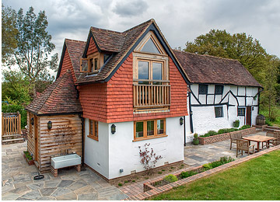
(East End Cottage)
We interviewed his twelve-year-old sister Helen to see what she thinks about this so called ghost living in her house; she said she does believe in ghosts but Thomas Kempe hasn’t done anything to her yet so she is extremely sceptical about it. “My brother is acting really weird,” she said “like he is sleeping with the light on, and he gets really anxious when mum and dad leave.”
Then we interviewed the ghost catcher himself. And he 100% sure there’s a ghost in that house< but if there really was a ghost why would it still be there, “We tried but he wasn’t having it!” Burt exclaimed.
We will keep you updated on this ghost; if you people of Ledsham find something interesting going on please contact us at 07896433226.

