The Ledsham supernatural
Young Master Harrison has been speaking of a ghost inside of East End Cottage. Recently, strange incidents around this small town have left the townspeople talking. Is this real or just a trick?

I interviewed the boy at the centre of all the dark commotion. James has stated that the ghost has been smashing pots, breaking models and writing bizarre messages. He handed us one of the letters the phantom had wrote: “I lyke not this quill.” The schoolboy has claimed to have asked Bert Ellison – the apparent ghost catcher- to get rid of the old-fashioned poltergeist. “He is the only person who believes me, “stated James tearfully. While the young man is in tenterhooks, we move on to his mam.

Mrs Harrison – who has recently moved here – claims that James is “lying and just wants attention”. She told us that she knows that there are weird things going on but thinks it is just James. She told us, “It’s all just a flux and it is all James being his typical self.” While Mrs Harrison is sceptical and confused, we move onto our final interviewee.

Yesterday, I caught up to the amazing “exorcist” in body and blood, Bert Ellison! He told us, “I tried to exorcise the ghost, but it definitely did not want to go.” He was very calm and relaxed about this whole poltergeist.

Things have been smashed around the Harrison’s lovely cottage. Is it really a ghost? If you see another supernatural incident, please call 08 300 880903.
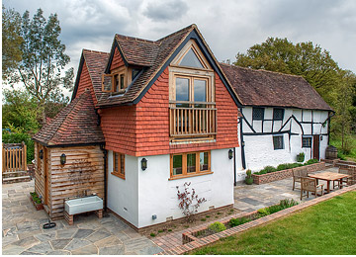
East End Cottage

