A ghost in a cottage, is harassing a young school boy. This boy is desperate to get the poltergeist. What Will Happen Next?
The Ghost of East End Lane
James, the 12 year-old boy claims there’s a ghost in his house. He said the ghost was breaking models and writing strange notes. The school boy suggests strange things happened at the local library. I asked why the phantom was doing this. He just looked at me and said I don’t know. I was confused at first but then figured it out. I guess Mr Harrison didn’t know much about the ghost.
Mrs Harrison claims that the school boy is just trying to cover up his tracks, so he doesn’t get in trouble. She said the young boy is typical but he doesn’t have to destroy his room and break his own clay pots. So at this point she didn’t really believe her son.
Bert Ellison is apparently a ghost hunter, a builder and a decorator; I guess he works hard. He said that ghosts normally come in pairs. He was the only one who believed the school boy. This so called ghost is a mischievous nuisance.
While James is on tenterhooks; waiting to see the ghost again, his family remain sceptical. If you have further information ring 6264666869
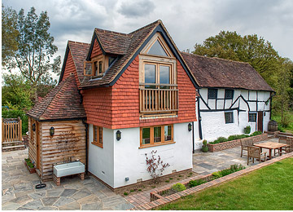
East end cottage

