DOUBLE OR HALF?
Suspicious trouble at Ledsham. A ten-year-old school boy harassed by a poltergeist. Strange incidents have been left all around Ledsham.
I interviewed the boy that is the target for all the mysterious happenings. James told me that models have been broken, and notes have been scattered everywhere. Bert Ellison is the only one that believes me. “My dog, Tim, has been barking into thin air.” said James.
While Master Harrison is waiting for the phantom to appear, the other members remains sceptical.
Now I interviewed Mrs Harrison (the boys mum). She said that she understands that her son is going through a lot, but I think he is playing a trick on me and his father. “His father and I also understand he is a typical boy, but we both think he is delusional.
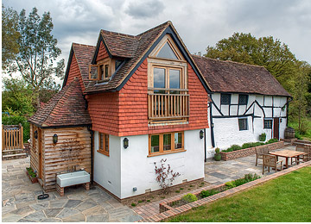
The cottage at East End Lane.

While Mrs Harrison still doesn’t believe Ghosts, we interview someone who does. Mr Bert Ellison.
Mr Bert Ellison is a middle- aged man who is very relaxed
Bert said that he is a local builder; he also told us that he has spoken to Thomas Kempe. “This ghost is hard to get and I am confused because what I’ve heard ghosts are known to come in pair…or more and James only has one!” explained the so called builder.
While James is patiently waiting got Thomas Kempe to come back, his family remain sceptical. If you have witnessed anything call: 01913334793

