GHOST OR TRICK?
A young Mr Harrison clamed there is a ghost in his house. Recently strange things have been happening. Could it be a ghost or is it a trick or something else.
We interviewed James, the 12 year old boy, he is the so called target of the ghost and all its mysterious doings. The young boy said “things have been smashed around my house such as: bottles, verses, and my window has been broke, “he said normally but he was felling anxious he said the worst thing is that he gets all the blame for everything and the person who is doing this is the ghost not me. He also said that the ‘ghost’ has been following him everywhere around like school the shops and everywhere around the house he states that the only person that believes him is the professional ghost hunter Bert Ellison. While Master Harrison the very edge, waiting to see the ghost again he remains sceptical. We interviewed Mrs Harrison,

Not believe in ghosts and she said that she does love James but she thinks he has went a bit crazy because there is no such thing as ghosts! She says she has just moved into the village and everyone has been nice and friendly. Is there a ghost or not; James believes but his mam does not. His mam says that James room is always a mess and this I problem just a big excuse for it all.
Bert the so called ghost hunter, clams James to have said to have said to James that they normally come in pairs. This made James confused and he started to think that there is more than 1 ghost in his house. He said he is also a decorator and a builder and when James said the ghost keeps harassing him and he is desperate for it to go.
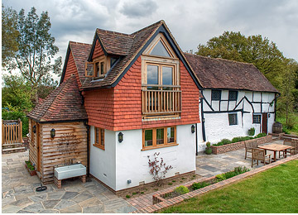
East End Cottage

