The Olde Englishe Ghoste
A few days ago, a young Mr Harrison reported a ghost in East End Cottage. Do you believe him
James, the boy at the centre of it all, told me that his dog Tim has been barking at absolutely nothing. “Why is it always me!” the young boy exclaimed upsettingly. The unusual notes have apparently been written, not only at home but at the little boy’s place of school and the village noticeboard. The schoolboy has been left with emotional scars all over. It seems Thomas Kempe is real and he’s got it out for James.
Mrs Harrison, James’s mum, says that she loves her son but thinks he is going a little crazy. “I’m punishing him and it’s not enough. I have taken away his pocket money and sent him to bed without supper and he still keeps blabbering on about these ‘weird situations’,” the housewife stated. A tornado of shock has swept over this woman and we hope this doesn’t affect their day-to-day family life any further.
Bert Ellison, a builder, decorator and so called exorcist has been to the house in question. He claimed that the boy is telling the full truth and he doesn’t seem like a boy who fibs. “As a builder, I have some stuff that can be used catch a ghost,” the middle aged man said rolling up a cigarette and putting it in the corner of his mouth, “the boy don’t need punishing and hes mum is too hard on him. After all he isn’t lying.
If you were to find any extra information please contacts the daily prophet at 08003624, we all hope this can further.
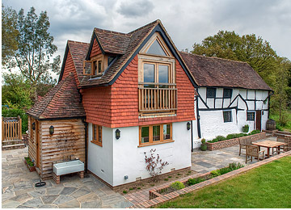
East End Cottage, Ledsham

