A young boy has reported how he has been feeling teased/attacked by a demonic presence. This recent event has started just a month ago. It has left everyone talking.
We have interviewed the young boy and asked him some questions about all of the paranormal activity that has been going on in his house and this is what he said…
Hello James my name is Luke and I would like to talk about all of the things that have been happening at your house. Ok he replied. First I just want to talk about how the vase fell of the table. Well I think he was ignored at me and was angry he stated. So you mentioned “he” do you mind to tell me who this is. He is a ghost named Thomas Kempe.
I have interviewed Mrs Harrison (James mother) Hello Mrs Harrison we would just like to ask you some questions. First, do you believe in ghosts? She very surprisingly/seriously said. Why of course not! And you must be crazy to think so.
Finally we interview Bert. Hello Bert we would just lie to ask you some questions. About what? He grumbled. Well I replied why would you like to work with a 12 year old boy? Because he asked me for help obviously. Bert the construction worker/exorcist? Is what the recent headlines are at BBA news and the moon Well I guess I’m famous he said with a smirk on his face. Famous in hatred you mean. Anyway how are you going to get rid of the ghost? I was so intrigued to hear the answer until I heard that it was a secret. Well it has been an absolute honour for you to answer those questions and if you want to talk again then just call 0716 523 646 but until then…o I almost forgot about my next live broadcast show on Monday anyway goodbye.
GHOSTLY SPIRIT HAUNTS CITEZAN?
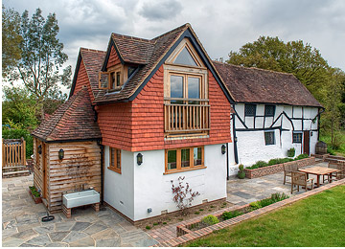
James’s house

