Last weekend, a ghost was spotted in a cottage in Ledsham. A young boy said he feels like he is getting targeted. He also claims strange things have been happening
THE GHOST OF LEDSHAM
I interviewed James, who claims he saw it. he told me that the first thing that happened was pots had been smashed and damaged .The ten-year-old schoolboy told me the dog had been barking randomly when its silent .The young boy also claims he found notes and messages in the town and in the house . Master Harrison told us he has felt this phantom “Bert is the only person who believes me, “James told us. Bert is apparently a ghost hunter .while James is on edge to see the ghost he move on.
Next we interviewed James mum .Mrs Harrison says he is just imaging it or he is lying. She also says he is a typical young boy. Mrs Harrison said “strange things are happening but I am sure it’s the wind.” James mam also said “I have been very welcomed to Ledsham.”Although she wants to believe James she thinks it`s all fake.
Yesterday, I met up with Bert Ellison - the supposed ghost hunter .Bert does believe James because he has caught a ghost before. The ghost hunter says he covers up his job with a decorator. He is a relaxed and well known man in Ledsham. As Bert believes James he just moves on and said “it was nothing to worry about.”
This is it from me today see you tomorrow at 6 good bye Mr Baptist.
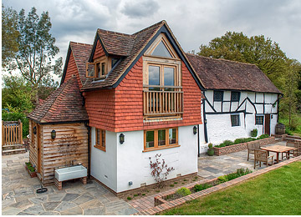
East end cottage

