Double or one?
Ghost in a cottage in Lensham. The town is messy could all of this be a trick.
I interviewed the young school boy who has discovered a ghost in his home James said weird things were happening in his home. Master Harrison also stated that his dog sense something in his room .James declared “I’m getting the blame and I’m sick of it.
While Master Harrison still believe in this his family is still concerned for their son; they are sceptical.
I interviewed the young boys mam She is concerned for her son; she doesn’t believe any of this .Mrs Harrison stated that she usually blames James because he is normally in bother .the young mother declared that her son is going delusional. Mrs Harrison stated,” my son is lying to me and I’m sick of it .I’m fed up.”
While Mrs Harrison waits for further notice. She still does not believe in this.
Before the apparent exorcist went to do a job, I asked him some questions. Bert Ellison quoted that he has recently captured a ghost from the church .he stated that he is the only one who believe the young boy. ”I believe James: I have experience working with a ghost before, “claimed Mr. Ellison.
James is still anxious about the situation; the family is hoping it will go away soon so they can live a normal life.
If you have any more information please call 0800222343.

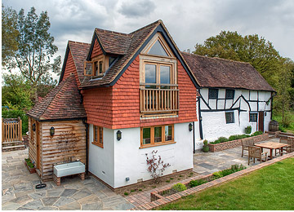
East end cottage were the ghost was discovered.

