Dear parents / carers
Thank you for your patience during these difficult circumstances. We have been unable to update you further about school openings until today as we have had to wait for advice and recommendations from the Local Authority. Their advice is:
In order to open Gateshead Schools to increased numbers of children safely, Headteachers have agreed that the initial date suggested by the government of June 1st is too early and, instead, have set a date of June 8th, at the earliest. The reasons behind this difficult decision were:

- It is generally agreed that Gateshead has one of the highest transmission and infection rates in the country for COVID19. We are, therefore, cautious about bringing large numbers of people together in a confined space for a number of hours. Although this position may be improving, the situation remains fragile.
- Schools have not had sufficient time to complete and consult on robust risk assessments.
- The Government has yet to confirm progress on their five tests, which is a key condition they set for schools to bring more children into school. This is not expected until Friday 29th May which is too late for an opening of 1st June.
- The scientific evidence is not yet conclusive regarding child to child and child to adult Coronavirus transmission. This is a significant issue when working with younger children where social distancing becomes impractical and unrealistic. If asymptomatic children are capable of spreading the virus the impact on families and communities could be severe. https://www.rcpch.ac.uk/resources/covid-19-research-evidence-summaries

As always, our priority remains that the children and staff are kept safe. A huge amount of planning and preparation between staff and governors has been undertaken to provide what we believe is the best option for the pupils of Windy Nook Primary. In order to keep staff and children safe, we believe we need to operate a rota system that will allow classes to remain small with staff and children exposed to only the same, small number of people each week. The government states that the youngest children and those children who are entitled to childcare have to remain our priority. As a school, we would like to be able to offer all pupils a period of time in school before the summer holidays. In order to do this, we propose that school opening will look like this from 8th June. PLEASE NOTE THAT THIS COULD BE SUBJECT TO CHANGE FOLLOWING FURTHER CONSULTATION WITH THE LOCAL AUTHORITY.

Week beginning | Children allowed in school
8/6/20 | Rec, Nurs | Y6 | Childcare provision will be open every week day to all children of key workers / vulnerable children no matter what year group they are in.
15/6/20 | Y1, Nurs | Y6
22/6/20 | Rec, Nurs | Y5
29/6/20 | Y1, Y2 | Y5
6/7/20 | Rec, Nurs | Y4, 3
13/7/20 | Y1, Y2 | Y4, 3

This rota will very much depend on how many children we have in school and therefore we would ask that you let us know as soon as possible if previously you were undecided and now, having received this further information, would like your child to attend or not attend. Please email Mrs. Gerry at windynookprimaryschool@gateshead.gov.uk or ring the school office if you have changed your mind about your child attending.
PLEASE BE AWARE YOU CANNOT JUST TURN UP AT SCHOOL WITH YOUR CHILD IF YOU HAVE NOT PREVIOUSLY AGREED WITH SCHOOL THAT YOUR CHILD WILL BE ATTENDING. STAFFING RATIOS WILL HAVE BEEN VERY CAREFULLY CALCULATED AND SO YOUR CHILD WILL NOT BE ALLOWED TO COME INTO SCHOOL.
Start and end of day - School will operate a staggered start and end time for each group of children which will allow for a minimal number of pupils / parents on site at any one time. This will also allow us to stagger lunchtimes and break times so that only 1 group of children are out on the yard at any one time. A text message will be sent to you the week before outlining your child’s start and end time once we know that your child will definitely be attending. Children who arrive at school late will not be allowed into school. Please ensure you keep to the strict time arrival and collection schedules you have been allocated.
Staff will be around school at the start and the end of the day to ensure that you follow our one-way system to reach allocated classrooms. Entry to school grounds will be via the main school entrance and the exit will be round by the nursery building. There will also be arrows and signs to help you. Please ensure you maintain the 2 metre social distancing rule between yourselves and other families and do not gather at the school entrance gates or doors. We would ask that only 1 adult brings each child to school thus minimising adult to adult contact. PLEASE NOTE THE BACK GATE WILL NOT BE OPEN AT THIS TIME.
Children will need to be taken to / go to their allocated classroom door at the allocated time, where staff will be there to greet them. Children will be asked to use the hand sanitiser before entering the classroom door.
Staffing – In order to keep class sizes down and contact with individuals to a minimum, your child may not be taught by their own class teacher or in their own classroom. In KS1 and KS2 the adult teacher ratio will be 1-9 and in the EYFS it will be 1- 5/6. You will receive a text message the week before your child is due in school telling you who your child’s teacher will be and which classroom they will need to be taken to at the start of the day and collected from at the end of the day. If you have children in school with different start and end times, please contact school via email or telephone to discuss arrangements. Below are photos of how the KS1 and KS2 classrooms will look.
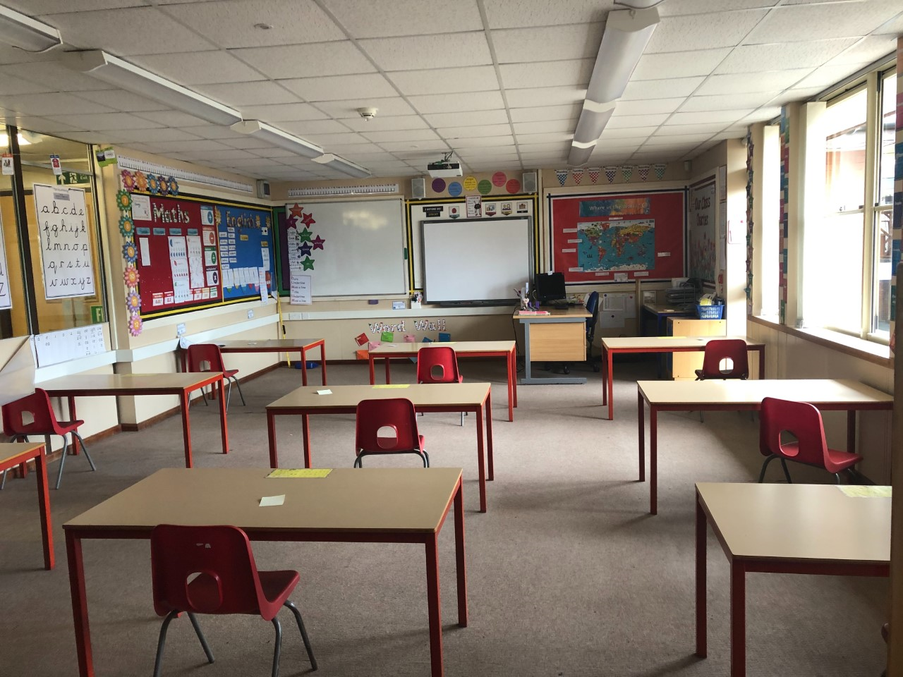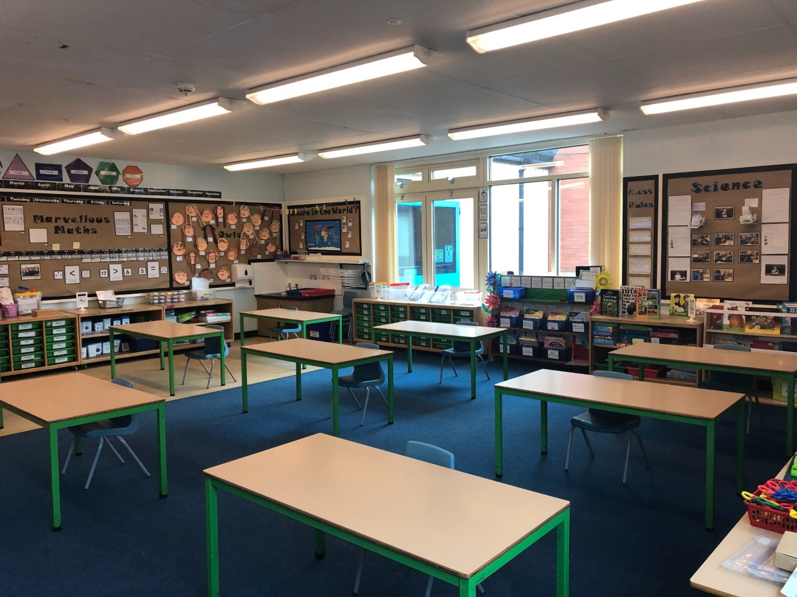
KS2 Classroom KS1 Classroom
Travelling to and from school – we have been asked by the government to remind you that you should avoid public transport if at all possible when travelling to school. The Fiddlers 3 Public House have agreed that you can park in their car park at the start and the end of the day in order to reduce the number of cars around school. The school car park is not to be used as we will have children on site from 8:30. Please ensure that older children do not walk to school with other children, apart from those in their immediate families.
School Uniform – Whilst we would prefer children to come to school in their uniform, we do understand that for some children their uniform may no longer fit. We would ask that as a minimum uniform requirement: children wear clean clothes every day, long hair remains tied back and that the children wear sensible shoes. We would also ask that children do not bring bags or pencil cases from home.
School office – Please note that the school office will not be physically open to parents / pupils during this time. If you need to contact the office staff or a member of staff, please email or ring school. If you need to meet with a member of staff a pre-arranged socially distant appointment will be made.
School lunches – the school kitchen will provide a packed lunch for those children who are in school or alternatively your child can bring their own packed lunch. Children entitled to Free School Meals or universal infant entitlement will get their packed lunch free of charge. All others will need to pay for their lunches online using sims Pay. Packed lunches will be eaten in classrooms and then children will have an allocated breaktime out on the yard.
Warm weather procedures – Please note that the school water fountains will not be in use. Please therefore provide your child with a named water bottle for use during the day. If we are lucky enough to have warm weather, please ensure your child has had sun cream applied before coming to school and has a hat to wear when outdoors as we are hoping to have some lessons outside.
Attendance – the government have made it clear that they would like children to attend school before the start of the summer holidays; however, they have made it clear parents will not be fined or penalised for non- attendance. We would ask that you let school know if your child is unwell and will not be attending school following the usual procedures. If your child displays any symptoms of being unwell, we would ask that you do not send them to school. Any child who displays COVID symptoms will be sent home and have to be tested. Any confirmed coronavirus will result in the class teacher and all children in that child’s bubble having to isolate for 14 days.
Home Learning – Staff will continue to set work for those children who are not attending school. Although they will be accessing similar learning to their peers who are attending school, this will not be exactly the same as we are not planning on delivering online learning for those children attending school.
Cleaning around school - All children will have their own equipment to use in school. Doors will be propped open to ensure that a minimum of surfaces are touched. Children will access their classrooms via fire doors and will only enter the school corridors to access the toilets. The toilets and corridors will be staffed during the course of the day to avoid any unnecessary contact. The whole school will be thoroughly cleaned at the end of each day.

EYFS Children - Reception and Nursery children will not be expected to sit at desks all day and will have access to some limited resources in a carousel. We know that trying to maintain a social distance of 2 metres will be very difficult for these children. We cannot guarantee that children will not come into close contact with each other, although with small numbers in each class we will endeavour to do this. The children will have access to the outdoors. Below are pictures of our EYFS classrooms.
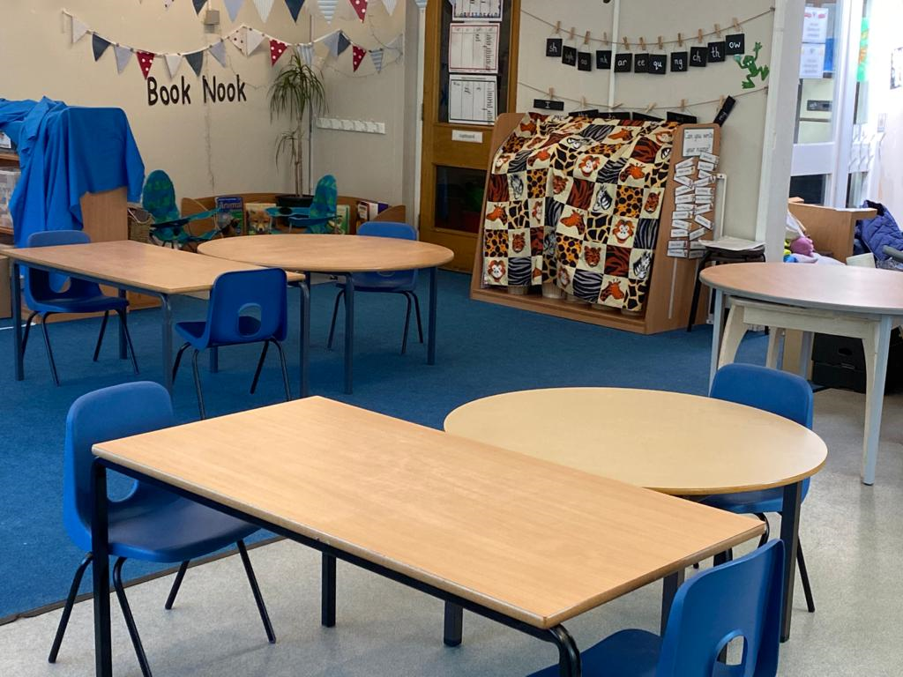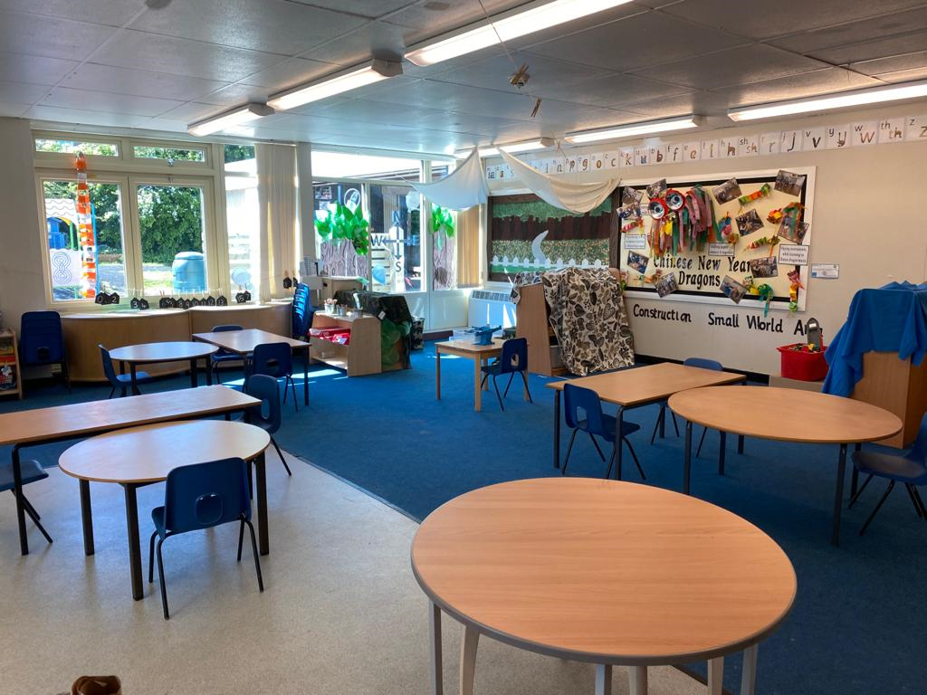
Hygiene -We would ask parents to discuss hand hygiene as well as respiratory hygiene with their child before returning to school. The e-Bug project is led by Public Health England and has a dedicated webpage for learning resources on hand washing and respiratory hygiene. Resources are currently available for KS1, KS2 and KS3 and can be used in various settings including schools and at home:
https://e-bug.eu/

In order to ensure the safety of the rest of the school community it is vital that any parents
choosing to send their child to school respect all government guidance and are not mixing with
others outside of their household. It is vital that we work together to keep the number of transmissions as low as possible.

We would ask that if your child’s year group is due back during week 1 or week 2 and you have changed your mind about them attending or not attending school you let school know via email or the telephone by Tuesday 2nd June. We will then send further information out that week to individual families.

If you have any further questions, please do not hesitate to get in touch. Parents requesting childcare will receive further information next week regarding a few small changes to our provision from 8th June.

Stay Safe

Windy Nook Primary School Team

