Step 1:
Open google classroom and log in.
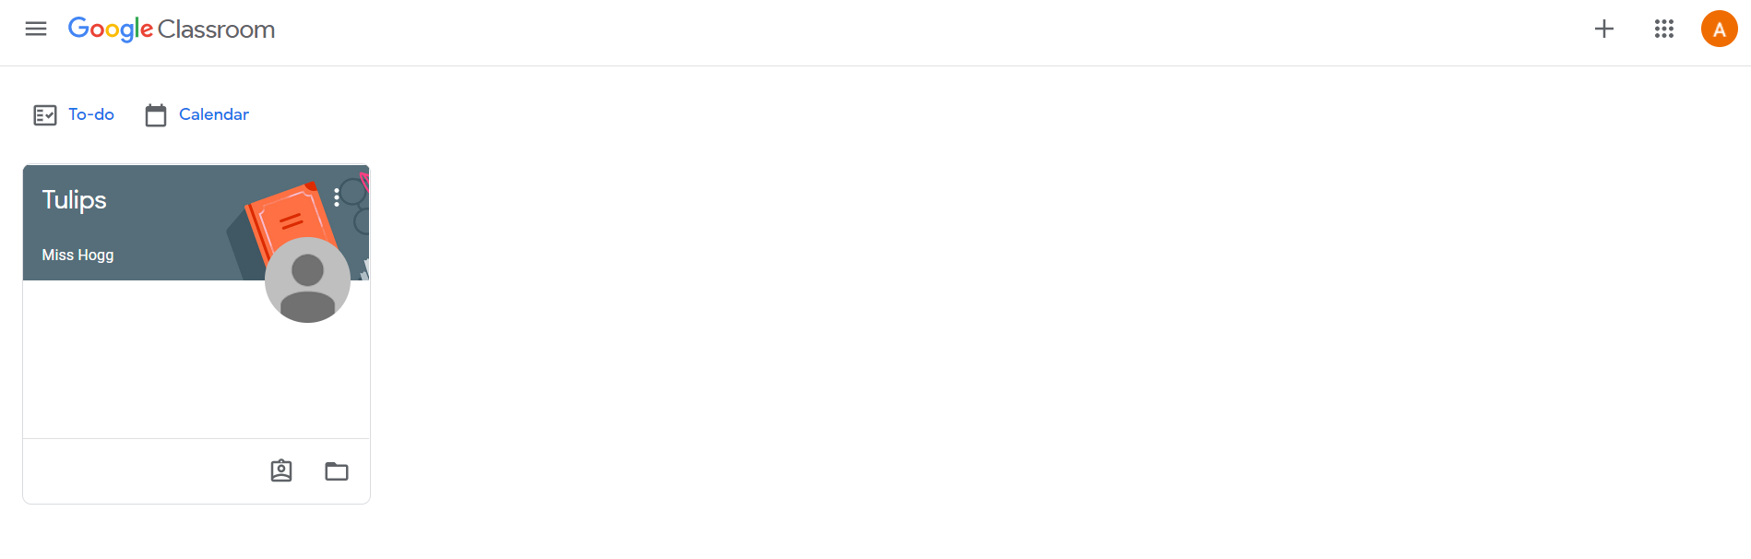
Step 2:
Click on the plus sign in the top right corner.
Step 3:
In the box below box type in the new class code sent to you via text and click join in the top right corner. This will appear blue once you type in the class code. Once complete you will be taken directly to the new class page on google classroom.
