Windy Nook News
Town Tumult
Mysterious commotion about a rocket being fired in Washington D.C.  by: A B  At 10:30am, at the centre of Washington D.C, a rocket was said to have been launched from the obelisk monument.  There have been reports of a rogue briefcase firing at innocent citizens here in Washington D.C. There are scorch marks on the street and even on the walls of local homes. This commotion has caused a lot of curiosity in the town. They are greedy for the truth.  Here we are joined by a local baker, Linda Smith,”I don’t remember much because when I was running away from the missiles I fell on my ankle and hit my head off the pavement but what I do remember is just chaos. It started like every other day, I served a few people then went on my lunch break and that’s when I heard this shooting noise. I went out to see what all this fuss was | 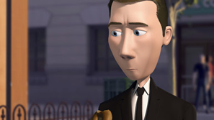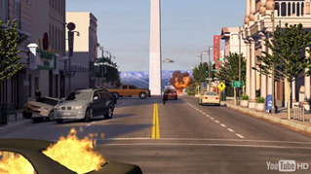  Walter Becket, last known location, Washington D.C.
 | about and there it was, this moving briefcase chasing me down the street. There was this man though. Dressed all in black but sadly that’s all I remember. Wait, now that I think about it I remember serving him. He was a nice chap. All he wanted was a bagel, but he didn’t speak much.”  Another witness claims that there was some sort of bird battling with the man that was dressed in black. We have found out by our trusty resources that this man's name is Walter Becket. If that is not enough mayhem, once all the shooting was over, there was this rumbling sound that spread | throughout the city. Eyewitnesses say there was a rocket that came out of the Washington Monument and that a man was flying on a briefcase beside this missile. An unknown source, who wishes to stay anonymous, states that the rocket was aimed at Moscow, Russia.  Moments later, there was a huge bang and the prices for the rocket came raining down on the town leaving the town buried in ashes. Cars were on fire, buildings were on the verge of collapsing and a man who used illegal use of legal equipment was on the run.

