Washington catch up:
Horror throughout D.C.
SUB-HEADLINE  by Abigail Graham  This Sunday, on Springfield Street, Washington D.C. was sent into shock when an in training CIA agent nearly destroyed our town. 12:45pm devastation in the streets began when Walter Beckett was seen on the scene. Manic occurred when cars began swerving left and right and fire was shooting up from road to road.  In downtown Washington citizens were confused when they saw deathly lasers being shot from a flying silver briefcase. Walter Beckett is being blamed for the crime including his companion pigeon. Many shops have been forced to close when their stores have been damaged by cars driving into them and losing income. And a number of kind human beings have been severely injured and sadly killed. People ran for their lives as cars crashed before their eyes, a poor woman who was forced to save herself has spoken.  “I could just see all of the peace in our city swiftly leaving and all I could do was run away from it, it felt as though war was breaking through while I was chased by a flying obscure thing”  Reports claim that a man matching Walter Becket's description was found releasing a giant rocket into the sky from an opening in the Washington Monument. Not many answers have released themselves which is why the government is attempting to find out what Walter’s motive actually was. Those who were stuck in their house could see a huge cloud of fog in the sky from the nuclear missile which stayed there for hours. It seems that now Walter is on the run but police are still on the lookout for this armed criminal.  A witness has claimed that a pigeon has helped Walter Beckett to destroy our city but could this just be because they are traumatized from the earlier situation, Isabelle Grace has said, “I am positive I saw a pigeon flying away from the nuclear bomb as it was falling from the sky”. | 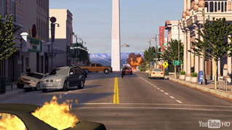  HAVE YOU SEEN THIS DANGEROUS MAN
 | Walter Becket has not been seen since the incident so many people who were watching this situation (who are a part of the CIA) have been sent out to go on a hunt to find this horrible man. If you see any signs leading to him then make sure to call 911 for backup ASAP as we have seen the destruction he has already made. If your house has been damaged from fire, falling stones, car crashes or any other, the government will be paying for your home to be renewed and fixed.  Knowing that this nuclear bomb was going to be sent to Russia, the most recent event if not handled correctly can cause an international war between us countries. With all our might we hope that Russia sees this as just a huge accident and not a clear threat. If something like this does happen Walter will immediately be brought back and will have to see huge charges.  A local shop owner by the name Suckie James told us about her experience with this disatour she told us that : “The floor began to rumble as a huge missile emerged. The floor shook and all you could hear was the sky being broken through with loud shouts. I could see my eyes not believing what was happening before me and I slowly closed the shutters on my shop to protect myself but then there was an echoing thud from outside”.  I am positive the government will reveal how to clean and help our town get back up onto its feet as soon as they can but until then there is now a public fundraiser for all shops that were destroyed. Hopefully with all our fingers crossed Washington D.C. main town area will be available to go to but from now on will be closed until improved. | 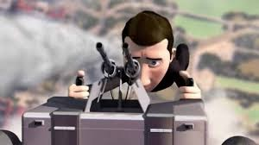If you see this man near you, you must call 911 and then as soon as you can contact this email address fixingwashington@helpfindthisfreak.com  The reward for finding him will be over 1000 dollars and if your shop was sadly destroyed or is now in pieces you will win a full helping team to help your shop improve.  Please contact us if you have any more information to inform our readers of Daily Washington Catch Up.

