WASHINGTON NEWS
THE RUMBLING ROCKET
SUB-HEADLINE  by Daniel Alcock  Chaos ensued when a briefcase started to shoot lasers across the streets of Washington DC.  We brought in a lady  called Linda Smith who works at the nearby shop called 7/11.  “Linda, did this man come into your shop?”  “Yes he did come in to my shop and he sounded like a calm polite man,”  In the heart of our, commuters were shocked to see this man destroy the city of Washington DC.  In downtown Washington, during rush hour there were people screaming and shouting because of the flying briefcase that blew up many cars. | 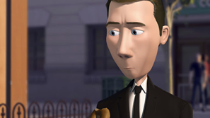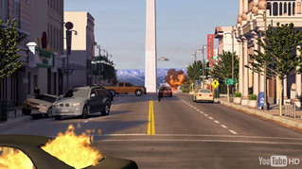  INSERT PICTURE CAPTION
 | Then all of a sudden the obelisk opened up and a big rocket came out and it was said it was heading straight to Moscow (Russia)  We have asked government if the rocket was aimed for Russia and the have denied that it was heading for Russia  A female who doesn't want her name to be out in public states that she saw a man dressed in black. Flew on a briefcase. | There is now an investigation going on just outside the monument. There are searches going on now for a man called water becket.  Hair: Brown  Race: White  Height: 6,2  Weight 167 lbp  He is meant to be hiding in a hideout in a mountain.

