The Daily Mail
Flying Briefcase Causes Chaos
A street in Washington was destroyed today by a mystery man,his briefcase and a pigeon.  by: Francesca Wraith  Yesterday afternoon, at around midday in Washington D.C. Walter Beckett, a junior agent for the CIA was spotted on the streets receiving a metal briefcase from another agent. He was last seen in a black and white work suit holding a bagel.  When he had opened the briefcase, a pigeon came flying over to have a taste of the delicious bagel that Walter had been eating. Kind as he was, Waltet tore off a piece of bagel and threw it expecting the pigeon to fly off and take it. Instead the greedy pigeon stayed where it was edging closer to Walter until… SPLAT! The pigeon threw itself in the agent’s face and not to anyone’s surprise he dropped the bagel so that the pigeon would stop the attack. But this wasn’t the last of the chaos that this pigeon caused.  The pigeon flew off in hopes to grab the bagel with its sharp claws but instead, the pigeon ended up INSIDE the briefcase! The pigeon was now inside the metal briefcase pressing all sorts of buttons and then, it saw a red button and pressed it once, twice too many times. The pigeon did not know this but it was actually shooting lasers whilst pressing this button! | 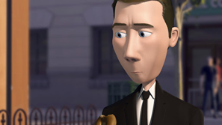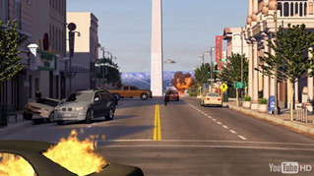  Suspect: Walter Beckett West Street after the attack
 | Then the pigeon started chasing this woman (we found her name was Libby after having an interview with her) around the city. The pigeon would not stop and then continued to chase Libby, this time also using lasers as a tool.  After all of this the pigeon pressed another button and made the briefcase equipped with a jetpack that allowed it to ZOOM! over the city.  Walter finally managed to bribe the pigeon down from the air by holding the bagel above his head. When the pigeon had come down finally the bagel ended up hitting the button that made a nuclear warhead shoot out of Washington Monument.  This was shocking but we are here now for a brief interview with Libby who experienced the whole mystery.  How did you feel?  I felt so scared the only thing I could do was RUN for my life!!! | 

