Windy Nook News
Rocket Rumble
A Rocket mystery  by J S  Yesterday at 11:30am, chaos ensued when shots were fired and buildings were damaged, people were running and screaming in the main downtown street of Washington D.C.  At midday on Tuesday, on the main street of Washington D.C, explosions were flying everywhere and people were screaming. A woman was getting chased by a mysterious briefcase. Eyewitnesses told us that they had to dodge bullets that were zooming towards their head.  In the heart of our city, commuters were shocked to see this much commotion. In downtown Washington during rush hour, citizens were shocked to see cars of fire buildings with holes in them and a briefcase flying about shooting lasers. | 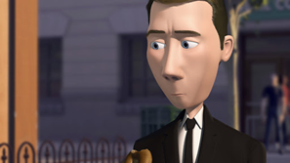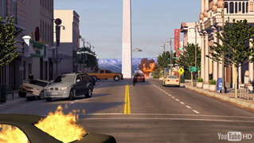  A man caused mysterious destruction!
 | A shop owner said she was doing her job making sandwiches in subway when out of the ordinary she heard a large amount of disturbance, so she went out to have a look when a briefcase just missed her face.  A large rumble came from the Washington Monument, a nuclear bomb it looked like emerged from the tall pointy masterpiece. People start to flee and scream. A weird man flew the briefcase toward this rocket looking bomb and shot a mini missile and the nuclear bomb blew up in flames and black smoke. | Ash fell to the ground as it landed on the civilians' heads.  According to scientists this bomb was heading to Moscow-Russia and if this had of happened it would have caused a full war. Was it a good thing that the man did to blow up the nuclear bomb or was it a bad thing? Apparently, the man who blew the nuclear bomb up caused all this destruction and his name is Walter becket.  NO ONE worries because we will be on the lookout for Walter Becket so if you see him pls call 999.

