Windy Nook News
Mysterious Box Destroys Washington D.C.
A mysterious box had destroyed a street called ‘Whale Street’ Washington D.C. with lasers!  by Rebecca Alcock.  Yesterday around 1:pm on Tuesday afternoon in Washington D.C. there was chaos in the streets. There were firing shots coming from a flying box. A CIA (Central Intelligence Agency) agent was doing it, but blaming it on a pigeon. His name is Walter Beckett.  In downtown Washington, during rush hour, citizens were shocked to see a box flying. Everyone in that street was screaming and running away. All these cars were turning around and speeding away. Some cars were on fire. Next thing we know, a rocket was rumbling. Suddenly, everything stopped.. when Walter Beckett held a bagel up.  The box lid opened up, and a pigeon was inside. The pigeon saw the bagel that Walter was holding and Beckett tried to get the pigeon out but it went straight back in and nearly shot a laser, until.. Walter threw the bagel and shoved the pigeon out. The bagel landed on the big red button.  There was a lot of rumbling and ‘BOOM’ the nuclear weapon launched. Everyone looked up and Walter had to open his box and look where it was going. It was going to Russia. Police cars were speeding to where the nuclear weapon had launched, but when you looked up.. Walter Beckett was in the sky trying to save Russia! | 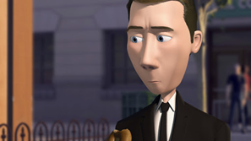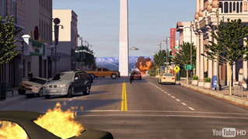  INSERT PICTURE CAPTION
 | There was that pigeon, on the top of Walter's box. He was ready to shoot a mini rocket at the big weapon but then the bottom part of the nuclear weapon fell off. He luckily dodged it. The bird was still there. Walter opened the box and then the bagel fell out and the pigeon went flying down for it.  He shot the mini rocket and it exploded and there was just black smoke everywhere. Before Walter came flying down, the pigeon was sat on the floor eating the bagel.  Finally, Walter came down. He saved Russia! But he still made the nuclear weapon launch.  Some people got some interviews,one shop keeper said,  “ I saw cars on fire, people screaming, and my shop was full of people trying to get away from all of the chaos!” Another lady said, “ I was traumatized, I was scared for my life! I thought I was going to die!” A Man said, “ I saw cars bursting into flames. I swear I saw a pigeon in that box.”  Citizens should be aware of more chaos like this in Washington D.C. because a lot of things like this have happened within this year. | The government will have to clean this all up because nobody else can. At this moment of time, this street is like a tip. There is just cars dumped on the roads.  If you see Walter Beckett please call  +103846294759  email policeofwashingtond.c.@ahol.co.uk  Walter beckett may have saved the country Russia, but he is still a wanted criminal as he had set off the nuclear weapon.

PAGE 1
]

