Bradely Chalkers

Letter to Carla

Mrs Ebbel’s Class

Room 12

Red Hill School

Last seat , Last row

Next to Jeff

Dear Carla,

Hi , I’m sorry I shouted at you . I was going to the barbers but then I realized you needed help . My mom said I had to get my hair done for Colleen’s party. So by the time I got my hair done and got to the school you were gone . Thank you for the time and effort you put into the letter and buying the book . So what page are you on in my parents stole an elephant ? Oh , aswell I got an A plus on my book report.

So I went to Colleen’s party !!! Jeff and me went because we're friends now . So I was really nervous because it was my first party in a long time. I spent a lot of money on her present like you said it is a gift from the heart !!! So when we got there Colleen was wearing a pretty red dress and the other girls too . Colleen’s mum took us to the back garden . I sat down at the table thinking it was time to eat BUT NO . I looked so weird sitting at the table by myself, thinking it was time to eat . Colleen’s mum said “That boy must be hungry !”Everyone laughed . I was so embarrassed and then I knocked my chair over and fell on the floor . Suddenly , a giant dog ran out. His name was chicken . He actually acted like a chicken. We played some games but GUESS WHO WON !!! I had won !!! For my prize I got a harmonica . So Colleen started opening her gifts and then she picked up mine . She opened the gift of course you said it was a gift from the heart . Inside of course was a replica of the human heart . I could tell she liked it . Everyone wanted one !!!! We ate cake too but I FORGOTTEN TO SING HAPPY BIRTHDAY !!! But it was fun .

Picture of chicken and party !!!

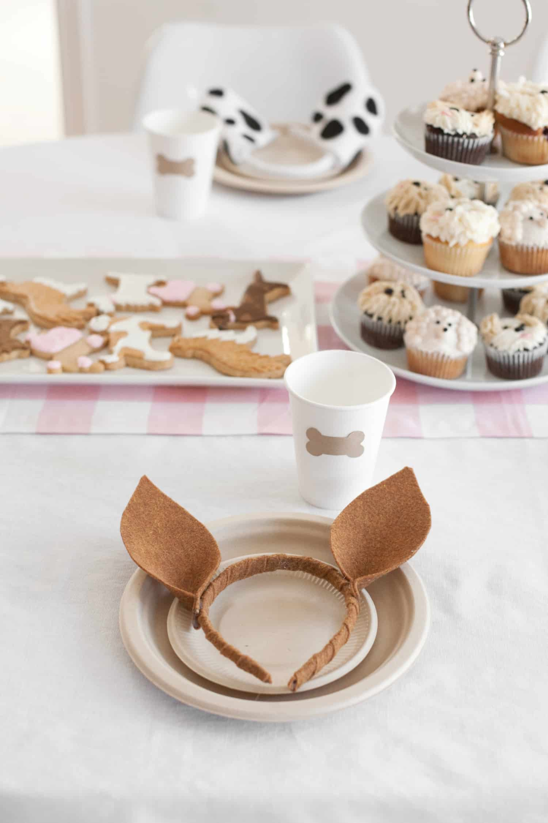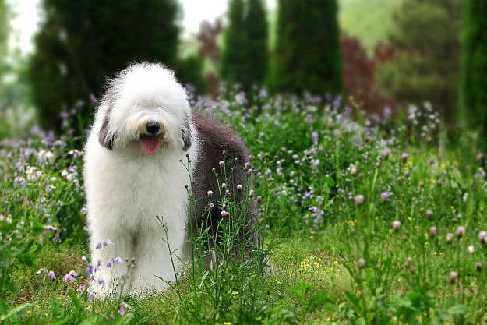

So how is it teaching kindergarten ? I think you should teach them how to do somersaults ( I failed at that in the party games ) and definitely teach them to sing happy birthday . You should read them. My Parents Stole An Elephant !!!There may be a surprise in the envelope too!!!

Love Bradely !!!

P.S. I have read it all!!!

