Bradley Chalkers

Letter to Carla

Mrs. Ebbel’s Class

Room 12

Red Hill School

Last seat, last row

Next to Jeff

Dear Carla,

Hi. Sorry I didn’t come on Saturday. I was getting my haircut for Colleen’s party and totally forgot. By the time I got there you had already left but guess what. I got first place on my arithmetic test and I ended up going to Colleen's party. It was so fun. I took your advice and gave her a gift from the heart. I got my mom to wrap it and put a bow on and Colleen absolutely loved it. So did the other girls. They were all saying how they wished they had one. After that, we also played some party games like a three legged race and somersault races. I ended up coming first place and I was rewarded with a harmonica. I was so excited to use it. I think it’s broken though because it was loud on one side and quiet on the other. Is that normal? Have you ever used a harmonica? Did you enjoy it? I enjoyed mine.

How’s kindergarten going? Are they annoying? You should teach them how to do somersaults. I’m going to practice mine with Jeff at recess. It’s going to be so much fun. We might even ask Colleen and Betty if they want to join us. Have you made any new friends yet? I have made five: Betty, Caren, Amie, Dena and Betty. I think they're my best friends now. I hope you like my picture I made you and enjoy working at Willow Bend school

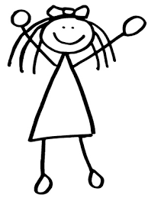

Love Bradley,