Bradley Chalkers

Letter to Carla

Mrs. Ebbel’s Class

Room 12

Red Hill School

Green Boat Drive

Last seat, last row

Next to Jeff

Dear Carla,

Hello! Do you enjoy teaching the 1st grade? I'm sorry I yelled at you, I really am. I wanted to come and see you but my mom made me go to the barber shop. Carla, I know when I yelled at you that it upset you. I don't really hate you , I promise. The only reason I yelled was because I was mad that you were leaving. I miss you, I really do. <3

I went to Collen’s birthday party on Saturday. It was so much fun! I think Betty and Judy have a crush on me. They're both nice girls but they stink of perfume. Anyways, when me and Jeff arrived at the party Colleen and her friends looked so happy to see us. I was relieved because none of them seemed to notice I had no clue what was supposed to happen at a birthday party.

The first thing we did was go outside to play some games. I was a bit worried because I forgot to bring my own chair but then I remembered that I didn't need to bring my own chair so that was good. The first game we played was the relay race, it was so much fun. My team won the running race but we lost the summer salting race because everyone kept on flopping on the floor. Me and Jeff were on a team for the three legged race. I won the whole thing. My prize was a harmonica. I was really excited at first but when I got home mom took it off me because apparently it was too loud.

What color shirt are you wearing today? I'm wearing a red one with black buttons and green stripes. Here are some pictures from the party to remember me by me by.

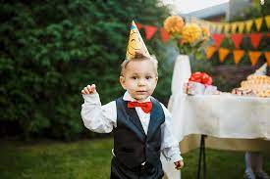

Love,

Bradley. <3