Bradley Chalkers

Letter to Carla

Mrs. Ebbel’s Class

Room 12

Red Hill School

Last seat, last row

Next to Jeff

Dear Carla,

Hi. What did u have for lunch today? Have you found someone to trade lunches with? Im sorry I yelled at you i didnt mean anything i said and im sorry I didn't come and see you on Saturday I went to get my hair cut at the proper place it STUNK of oily gum.Once I was done I came to see you but you had already left.I was hoping to see you in your colourful shirts.Do the children where u work like your shirts? Which on is their favourite? Mine was the one with the mice on it I liked that one at lot.

Guess what.I went to Colleens birthday party (with Jeff) it was so fun! We played lots of games and I didn't sit on the cake and i gave Coleen a present (she loved it).She asked what it was I was about to tell her but then Jeff nouged me and told me not to say (even though she asked) Was I being impolite? I hope shes not mad,it was a gift from the heart like you said.I won FIRST place in the games Colleen's mom had a chart and mine had the most points on it we played:Relay race,hopping race, three legged race. Can you believe it! We all got a dip in the box and Jeff got a dolls dress. I was a bit nervous at first I mean what if I sat on the cake again What if I offended one of the girls and Lori beat me up again but it was all fine you should teach the children how to do a somersault all the girls like me now they were cheering for me when i was running. I think I impressed the girls they seemed to be surprised that I was so good.I ripped my pants. Jeff had ripped pants too so I ripped mine in the exact place he had a hole in his right above the knee. Do you need ripped pants to go to a party? When Jeff came I seen his present rapped and then I started to panick I had just realised that all presents need to be rapped (with a bow) it needed to have a bow so I yelled at my mom to do it for me but luckily she was already doing it for me.

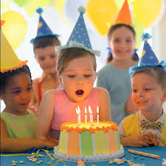

School is going well too i've started listening in class instead of scribbling and cutting paper into stars I got a 100% on my maths test.Miss Ebbel gave me a gold star just like Jeffs.People don't call me names now and the boys let me play basket ball with them I wish you could play.Me and Jeff are good friends now we go to the park together and we play soccer together hes coming over for tea tomorrow and I can't wait.Mom is gonna make us milkshakes (any flavour we want) I want strawberry and I realised that a milkshake is made of milk you probably already knew that. What shirt are you wearing today? I miss coming to see you when I come to school but schools alright now im liking it at lot better now that I have friends.Since Jeff got new friends and I became friends with Jeff again Im now friends with Jeffs friends at first they wanted to beat me up but now they like me and I like them. Every recess we play basket ball they taught me how to dribble and now im really good best player on the team.

How are you Carla? Are the children annoying? Do they always want to play? Do you go home with lots of paint on you? Are they well behaved? Did you like this school better? I hope your doing well and I hope you like your new job its a new start for the both of us. Do they have gold stars at your new job? Does any one have one? I hope you write back. I miss coming to see you to say thank you for being my friend I have a gift from the heart (Its my favourite)

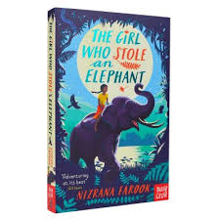

Love

Bradley