Gateshead Daily
Storm Arwen strikes u.k
Storm Arwen leaves 30,000 people without power and many homes severely damaged  by Your Name: Asmau  This week,Storm Arwen strikes the whole U.K,particularly Scotland and the North east.An amber wind warning from the north east and england from Alex deakin that the wind on on Friday was more than 75 miles per hour. “Disruptive winds of ver 75 miles per hour are forecast. The low pressure system will bring the worst of storms on FRiday and into Saturday”Strong winds and cold weather would also be on Friday and Saturday. Disrupted travel and infrastructure were all included in the whole U.K despite, with Power cuts and damage to property an environment. | 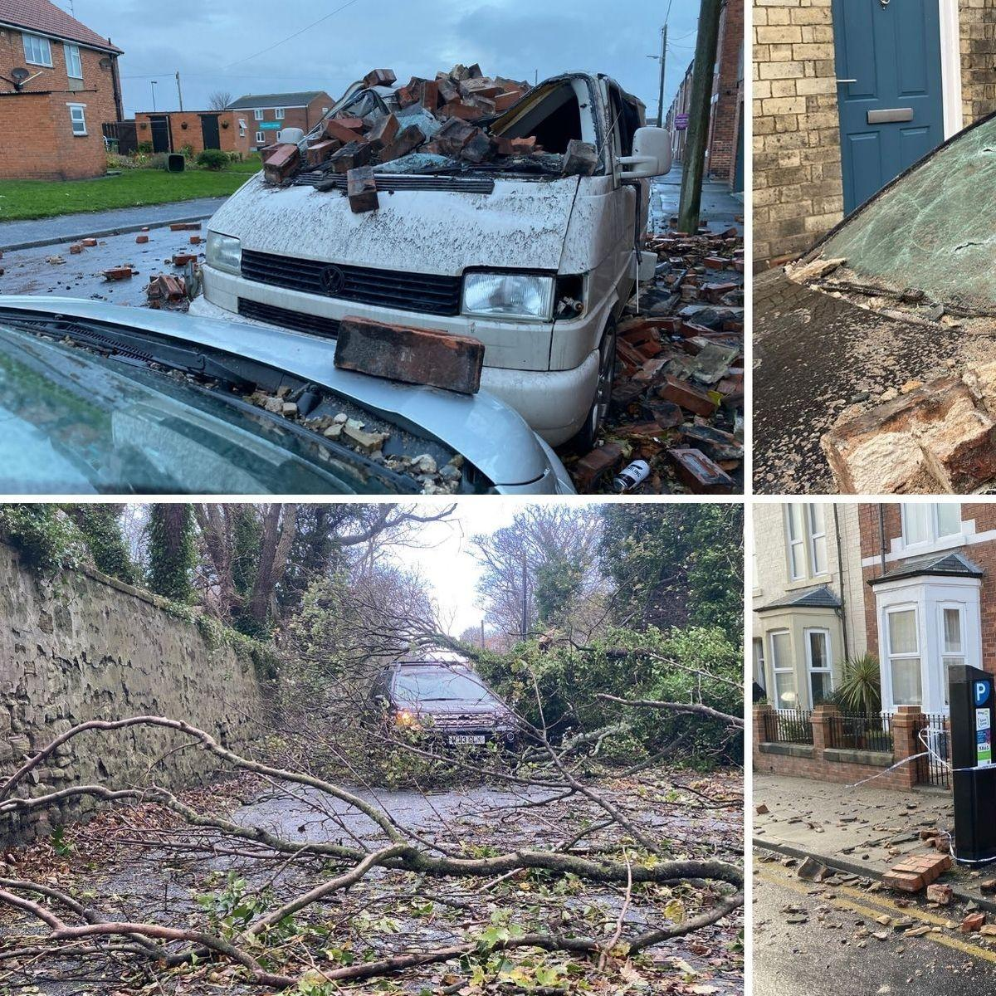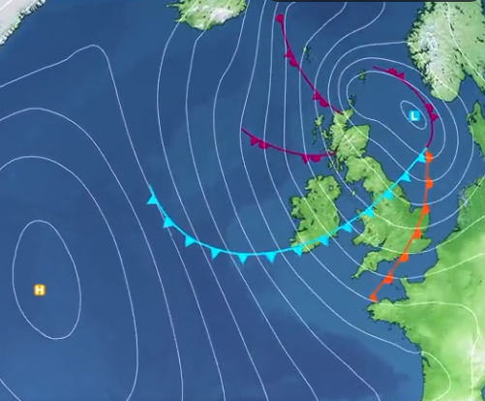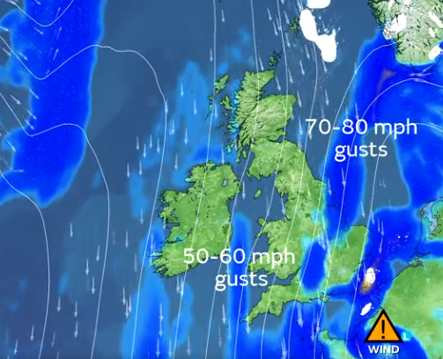
 | 30,000 people in part of te U.K,have been in loads of trouble including this boy named Luke James, a ten year old boy who lost his roof, lives in Durham and sadly and sympathetically couldn’t go back before Christmas day. ”I was devastated when I couldn’t go back for Chritsmas,”Jane Brown who was disabled is relieved and thankful that the electricity is back from several days from rain and snow in Northumberland, Morpeth.  “I feel so thankful ,I thought I wasn’t going to survive!  Luke is still not back in his home.Repairs are underway. Jane’s power has but she is campaigning for better infrastructure in the North east. | RAC expert spokesperson, Simon Williams.  “High winds can seriously affect vehicle handling, so drivers need to make sure that strong gusts don’t take them by surprise”  Luke is not back home. repairs are underway.  Jane Brown’s electricity hs come back from several days of rain and snow and suffering.  “Northern Power grid apologised for the delay in getting back power, they admitted it would  be Wednesday before everyone would get power back ”

