Windy Nook News
STORM ARWEN
Wind causes havoc in Morpeth.  by Drew  On Thursday 24th November 2021, Storm Arwen was named. Storm Arwen came across the UK causing many buildings to collapse. The locals of the Uk were not happy to find that their power went out across the Friday to the Saturday. Some residents are still without power. People in Northumberland are saying that they are being forgotten about. Northern Powergrid are trying to get the power back up and running.  An amber wind warning was put in place and people were advised to stay indoors because there was disruption to travel. Many houses were damaged in the storm. After 8 days 5000 people are still without power . The wind was speed more than 75mph. There were strong winds and cold weather from Friday to Saturday. There was disruption in travel, power cuts and damage to property. Some pupils were angry that they were still without power. The army was deployed to make sure people were safe.  Jane Brown, disabled lady from Morpeth Northumberland, was left without power for 9 days. When interviewed she said”It was so cold I thought I wouldn't survive !”  Julie Smith, a single mother who was without heating and power while trying to care for her young children.When interviewed she told us “It has made me feel desperate.”  Callum, a 10-year-old boy who lost the roof of his family’s home. When we spoke to him he told us “I was devastated not to be able to spend Christmas at home and play with my toys.” | 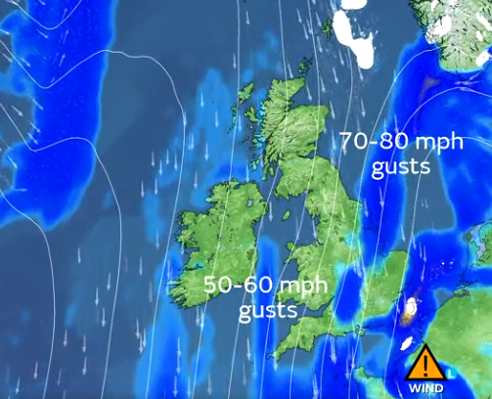There was a 70-80mph wind up towards Scotland and 50-60mph at London.
Alex Deakin, who is a well-known meteorologist. He works for Met Office. Stated that,“Disruptive winds of 70mph to 90mph are forecasted. The low-pressure system will bring the worst of the storm on Friday and into Saturday.”

Now 2 week after Storm Arwen Jane has power and Callum is staying in a hotel. Julie has got heating and her kids are warm and safe back in her home after staying in a hotel for 8 days. Northern Power Grid have apologised for the delay in resolving the outage but admitted it would be Wednesday before everyone had their power back on.

