The Oak Times
Storm Arwen Strikes The U.K
30,000 homes left without power and major damage  by Esther  This week, people in the U.K, particularly the North East have been affected by Storm Arwen as it hits the region with high winds and severe weather. The storm took place in the whole of the U.K. Scotland and the north east of England were the worst hit as the worst nights were the 26th/27th of November.  Experts have said a red warning for the North East with wind speeds more than 75mph. Friday and Saturday had strong winds with a mixture of cold weather causing disrupted travel, power cuts and damage to properties. Jane Brown, who is a disabled woman has said, “ The storm has cut off all power which has affected me in a bad way as I rely on electricity for many vital aspects of my life.  Many places in the north east have been severely damaged, with roofs falling off, doors | 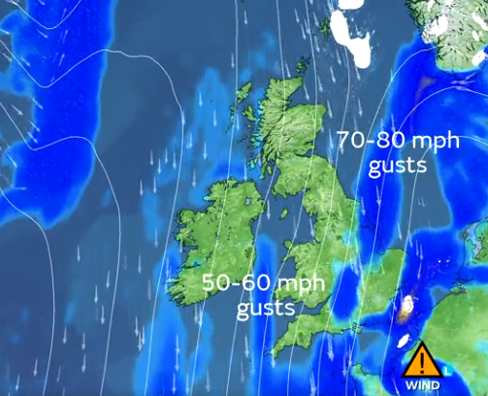  Amber wind warning for North East.
 | crashing down and many businesses without power.  30,000 people tried to survive without any heating and roofs for 6 day , so much damage that families had to evacuate their homes. A ten year old boy, George Smith, says “I couldn't spend Christmas in my house due to the storm taking our roof, we now have to stay in a hotel. “ I am just upset.”  Another family that has been affected by Storm is Jennie Green, who is a single mother with three children. She said, “ Everywhere in my house is freezing cold, my children come downstairs in the dark, shaking.I have to put wood into the fireplace just to keep warm.  Experts have explained that it is best to stay home and try to keep you and your family safe as the wind was a life risking situation, winds reaching 98mph. Having a temperature of 3-6℃. | RAC breakdown spokesperson, Simon Williams has reported, “High winds can seriously affect vehicle handling, so drivers need to make sure that strong gusts don’t take them by surprise.”  Alex Deakin ( meteorologist) MET office, “ Disruptive winds of over 75mph are forecast. The  low-pressure system will bring the worst of the storm on Friday and into Saturday.  “Northern power grid apologies for the delay in getting the power back on. It would be Wednesday before getting any power back. George is still not back in his home. Repairs  are underway. Jane’s power has come back but she is campaigning for better infrastructure in the north east. People in the north east are demanding a better response from the government in times of crisis.

