Krew Kronical
Storm Arwin batteres Britain
Sub-headline  Jessica  This week storm arwin destroyed most of Britain leaving millions of falling trees and houses! Trillions of people had no power for days in Northumberland which meant they were freezing cold and they couldn't cook a lot of things. We will be interviewing people on page two. A Lot of people feel angered because if the power went off in London the power would be back up in a couple of minutes. Over a hundred people feel forgotten about and tons of people are saying this just isn't good enough.The power company hugely apologises but some people don't forgive them. The army,who were very helpful, helped those whose power was off.  As Well as all of the power being off,people had to stay in their living room with the fire on and the doors shut because if you opened the door, it would become freezing cold. “It felt like if you went outside the living room,you were going into a bath of ice”according to a lady we interviewed.The power company says this won't happen again as long as we have enough people but should we forgive them?The weather warning was an amber that day meaning that there was going to be high winds and rain but no one was expecting it to be as bad as it was.  The areas most affected were the U.K,Scotland and the north east of England. The worst nights of the storm was on the twenty six and twenty seventh of November when the storm was throwing gates at peoples windows. The storm, that was ripping up houses,had finally ended on the twenty fifth of November 2021. The power outages were 225,000 and the maximum wind gust was 177km/h (110mph;96 kn in settle and england. And finally the fatalities were three. A storm like this is obviously going to happen in the future but the question is when a storm might be happening .It might even be happening right now as you're reading this. | 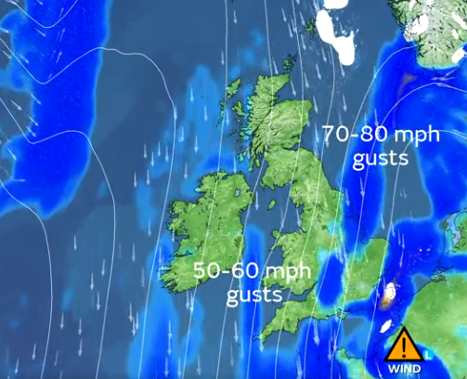zz
 | A disabled lady from Northumberland who's called Jane Brown,fully relies on electricity to live but since the power went out,she was in a humongous panic.When interview she said “It was so cold I thought i wouldn't survive”.Next,a nice boy called Callum, had to live on the streets because the storm had demolished the roof he had on his house!The storm has flipped over trucks and caused a tsunami of trees to come crashing down over parts of Wales, Scotland and England.On the news Alex Decan (a famous meteorologist) forecasted it on the news and like i said on page one,there was a amber warning.Thank you for reading Krew Kronicle with a k and well see you next time bye!

