Windy News
Storm Arwen battles Britain
Sub-headline  By Lucy  A week ago, Storm Arwen pounced at Britain leaving residents with no power . Storm Arwen started late Afternoon and was still causing destruction early morning .The storm took down garages and even residents roofs which left residents stuck in local hotels . This storm was located in the North East but turned Nationwide throughout the night.  An amber wind warning affected the North East , Scotland and England . We do not recommend travelling around the Uk because of the destruction and danger storm arwen has brought to us. As well as travel affected more than 5000 residents are left without power. Some residents are left furious about the time waited for power , most residents feel forgotten and left out . Every day soldiers are paying a daily visit to the local residents . The one thing that's keeping everyone's head up is the community spirit .  yesterday morning we interviewed Jane Brown , A local resident left without power . A spoken word from Jane was “I was so cold I didn't think I would survive”. Throughout the interview we asked Jane Brown a lot of questions to see how she experienced the terrible Storm . Because of the questions we asked we got to kind of experience the terrors Jane Brown went through . Jane Brown said the most big struggle of all was living without her hoyce. Her hoyce helped her into bed and helped her to get  on the toilet . She also told us how hard it was to get around in her electric wheelchair. Jane Brown also mentioned the amount of fridge food that was wasted. | 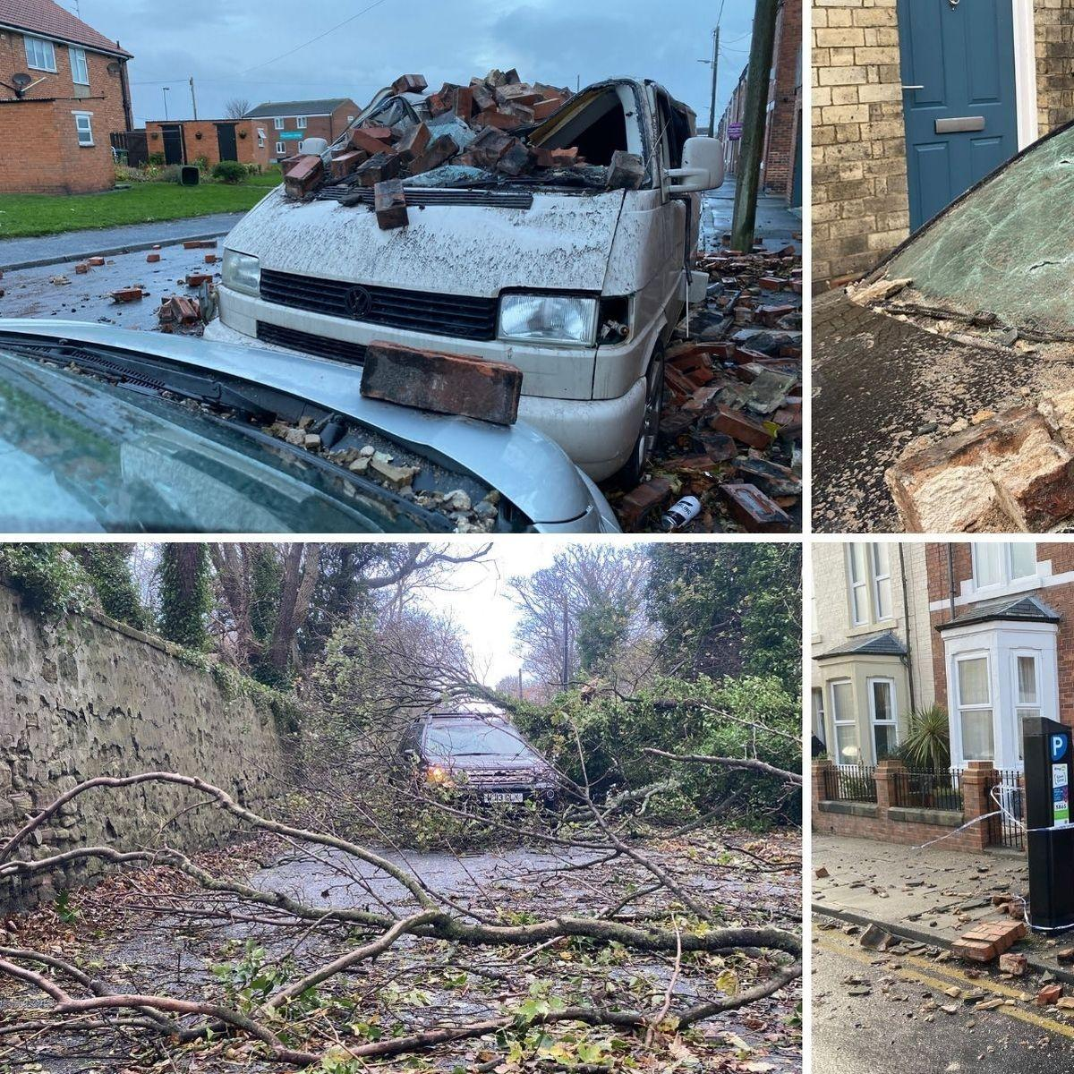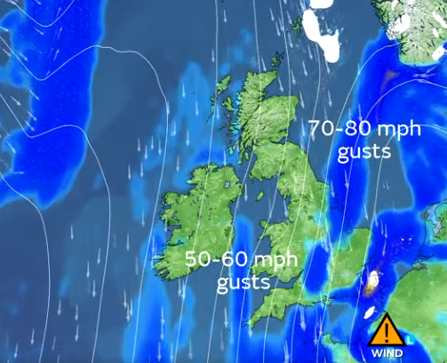
 | After interviewing Jane brown we went on to interview Alex Deacon who is a well known meteorologist . He told us that the storm's speed was going 70-80 mph .He also told us that the wind would be clear at about 3pm on Saturday afternoon.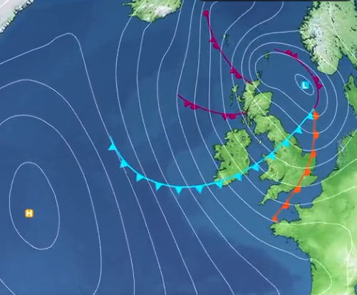 | After speaking with Northern power they said “Next storm we will definitely have a generator ready”.And we'll definitely send someone out immediately to fix the power . They also mentioned an apology from northern power for the delay .

