Windy Nook News
Storm Arwen Blows Away UK
Storm Strikes in Morpeth  by Morgan  Residents of small villages and big cities alike face struggles after the overpowering winds of Storm Arwen. Emergency services struggle after extreme cases of injury being reported from across the country.  In the small area of Morpeth, most are still without power days after the storm struck. Northern Powergrid has put generators in place to help cover small outage issues, however the problem is still occurring in many places in England. Chaos caused by the storm is plentiful, and much structural damage has been caused. There have been incidents reported of cars and vans being struck by objects swept away by the storm. The nationwide storm was starting out small but became a threat when the expansion of high winds began to occur. From the late afternoon of Friday the 25th of November 2021 to early morning on Saturday the 26th, Storm Arwen’s major destructive phase was just the beginning of the rage of citizens across Britain. A tree falls, followed by many others, destroying properties and vehicles across England.  An amber wind warning was put in place for the North-East of England and the South-East of Scotland. With much disruption to travel, trains, which were often delayed because of the storm, were packed full of the passengers who were meant to be boarding previous trains for days after the cancellation of many ways of transportation, most relying on standing on the train. Residents of the North-East were left without power for days after the strike of Storm Arwen. People in Northumberland rage after days of having nothing done about their power shortages, cold and without light for over a week. With 5,000 people still without power in their homes over a week after Storm Arwen, the army was deployed to support those with little food and warmth left in their house. The community spirit of the town is what kept Morpeth’s residents going and supporting the community was Jane Brown, a resident of Morpeth who stated when questioned about her experiences,” It was so cold, so bitterly cold. I didn’t know if I would make it. My wheelchair and thrust depend on electricity, which made my life a struggle since I couldn’t move around much to get food from my cupboards.” | 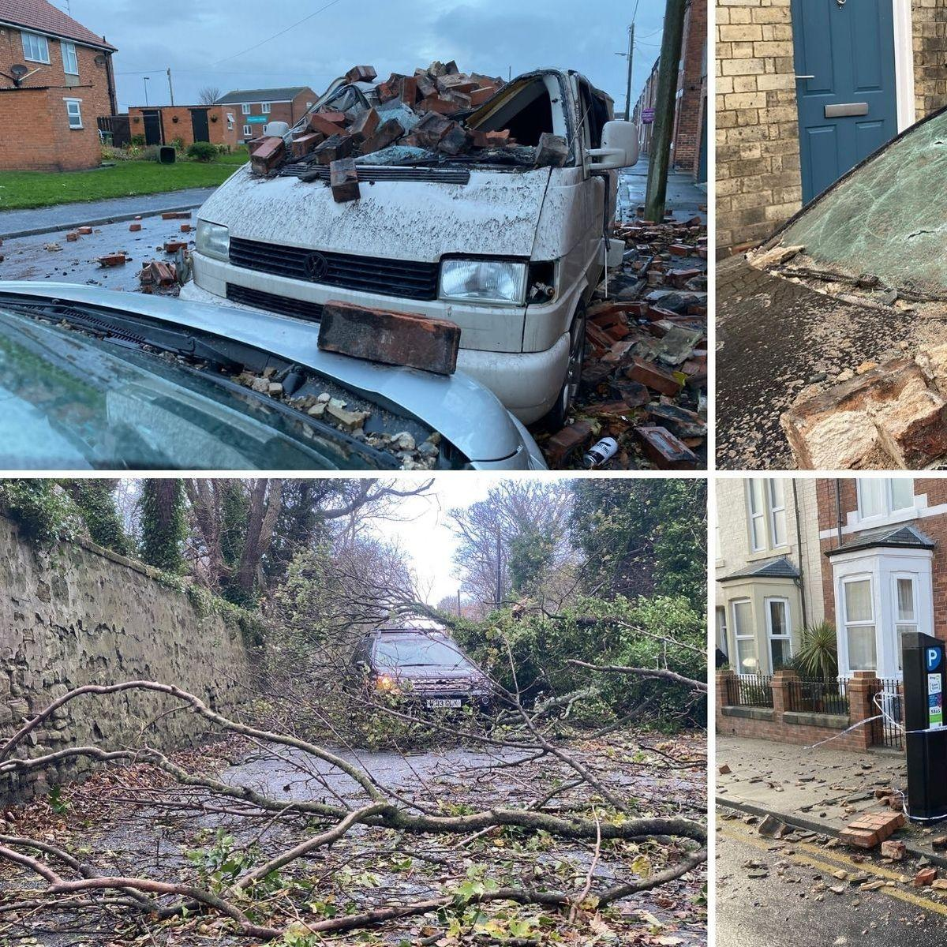  Mass destruction in small towns was terrible, causing vans to  be crushed by falling bricks and planks of wood. Dust flew  around all of the debris and mass destruction has caused  evacuations to hotels for many in the path of destruction  caused by Storm Arwen. Alex Deakin, a famous meteorologist,  stated that Storm Arwen was a powerful storm with winds  reaching around 70-90 mph winds.  Destruction caused by Storm Arwen.
 | Meteorologists across the country forecasted Storm Arwen days before the event struck. They also stated that the storm would begin to drive south and start to disperse as it would leave the UK. Many warnings have been put in place for wind, snow and rain. Whilst many still fear to be left without electricity and heating, power companies across the country have confirmed that all residents would have power by Christmas. 70-90 mph winds would make working and using public transport difficult on the days of the vicious storm.  Sharp winds slashed windows and ripped bricks out of houses. All through the night there was the sound of wind wrapping itself around homes across England and Scotland, amber wind warning in place throughout those two countries, dangerously strong winds throwing large objects aroused, snapping power lines, resulting in a nationwide outrage. | Fallen tree blocking road. blocking the road.

