Newcastle Times
Storm Arwen strikes England!
Latest reports show 100,000 without power!  By Ty  Storm Arwen was a powerful extratropical cyclone that between 26 and 27th of November has caused thousands of pounds of damage across England and Scotland, recent reports from local power companies show 100,000 have already lost power as winter begins, for some this has brought them to breaking point!  A train in Aberdeenshire, which for those who don’t know where that is it’s in Scotland, a train carrying passengers was halted overnight due to fallen trees onto railways resulting in many routes being temporarily delayed or cancelled!  Unfortunately 3 people have been fatally injured due to the storm, mainly from falling trees.  We’ve interviewed direct witnesses of recent events from Storm Arwen within the Tyne and Wear.  Julie Sharp, local citizen of Tyne And Wear  “We haven’t had power for days, I'm beginning to lose hope as I try to make sure my children are warm, our fireplace is our last hope for warmth until power is restored.”  Daniel, child  “When we woke up, the roof had been blown off and we had to move, our furniture had to be moved downstairs as the ceiling was weak.” “I could barely move through my own living room, we were in a hotel over Christmas, I was devastated, I hope I'm home for Christmas.”  Keith Anderson, CEO of Scottish Power  “Recently we’ve been overwhelmed despite support from local councils attempting to repair storm damage and return power to isolated communities, we guarantee the British Public that power will be returned!”  For those curious about the highest wind speeds, an average of 69mph, that is 60kt, was felt across the North East with highs of 98mph recorded in Brizlee Wood, Northumberland at 85kt. We believe winds were especially strong near the coastline.  To give you the scale of the damage, outside of our office there were fallen trees, damaged doors, collapsed fences and a pizza box in the car park.  The Government has responded to recent events in the north, providing aid and funding for repair, this has been the worst storm on record to hit England since 2005.  Tired, thirsty and need a drink? Well you're in luck as Orion Water is the finest in the UK! Purified water and cold water from Ice! The UK’s best fresh water drink! Buy today for as little as 2.99£! (Not Available in Scotland) | 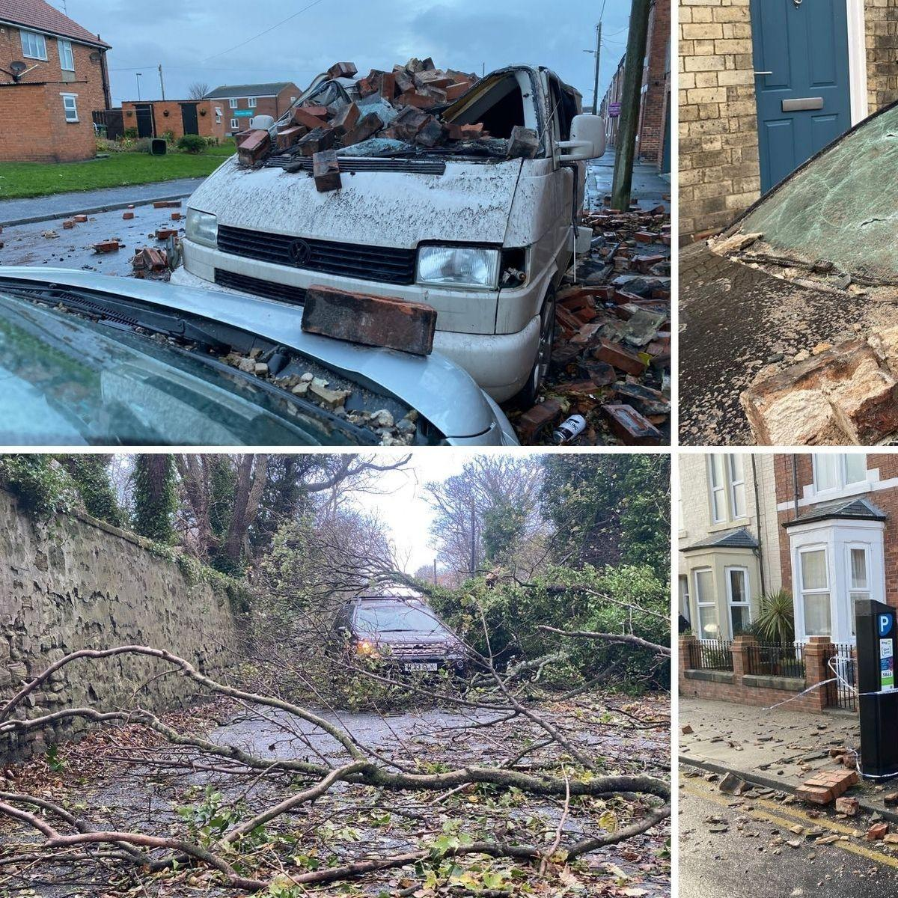
 | Although the worst problem, wind wasn’t the only result from Storm Arwen, large amounts of snowfall and powerful waves struck alongside the wind! Snow is extremely rare at this time of year and was incredibly thick.  This abnormal weather was especially common within areas of Scotland and Northern England. | 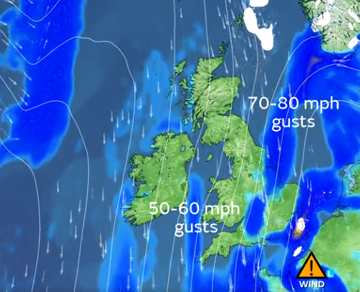  Official reports from the Met Office  Newcastle Times, produced and manufactured in Gateshead, not copyrighted. 2.50£

