Windy Nook News
Storm Arwin Attracts UK
Sub-headline  Storm Arwin is here.  Alfie  This week a storm comes to the uk destroying thousands of houses.Did you know a lot of power in the uk went out and it took a long time to get it back.Storm Arwin,which I think is the worst storm that has happened,has destroyed so many things.Many people were involved everyone in uk.In durum near an Aldi it hit 98mph (equal to 157kph) and amazingly  Some parts of the uk hit 100mph (equal to 160kph).There was cars,vans,lorries,bikes,  and good cars like audi and porsche.  They interviewed Jane Brown who is a citizen of and north east being forgotten she thinks.Also we interviewed Alex Diken who is a meteorologist.I would say it has been incredible for this amount of damage.Jane Brown said”If london went out of power it would be on in a hour or 2.  Alex deken said it will go through saturday and some snow warnings in place of the uk.  The storm was destroying things. There was bins,wood,twigs and fences.There was a ford fiesta with a trampoline on its roof.There was a amber warning taking place taking a big chunk of the uk and lots of snow. There will be hard to travel warnings by the storm.8 dates after the storm not all power is back to the uk.5k people is still without power in the uk.The army is in the uk chequing everyone with no power.Some people are going to one hotel to another.  We interviewed Jane brown she said “I thought I would die it was so cold “  Alex decen said lods of things about the storm.He had to forecast it on tv.There is going to be windy and cold after it goes.There will be 70 to 90mph winds also is 112mph (equal to 144 kph).There are several wind warning taking place and scotland is expected to have snow about 4cm deep.People who don't drive it will be hard it go to paces since another storm is jew around Christmas like 14 or 20th December.  If you need to go somewhere in the storm plz check outside and sea how bad it is and how some people have no home and no place to stay.I hope everyone is save . | 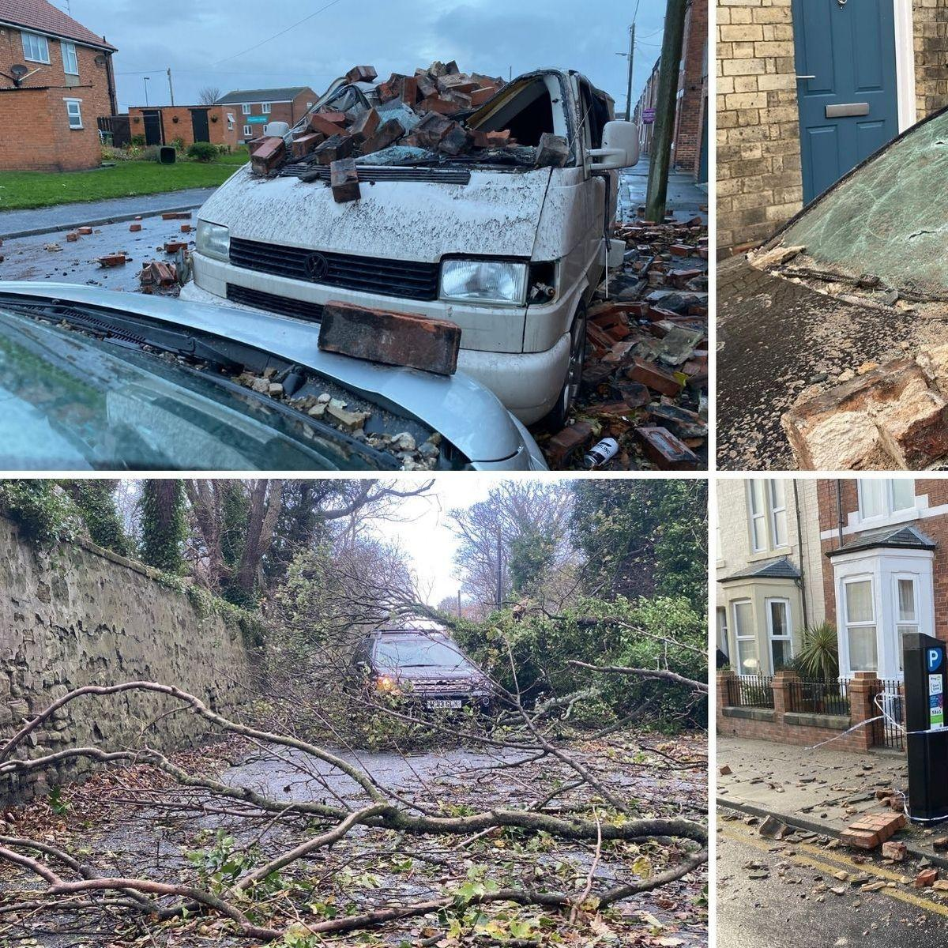
Jane gets her power back 8 days later.Some people still don't have a home but are staying in hotels.The power company will try get the power back by next week.In the future they will try their best to get to bigger places first.Hopefully it does not happen again. I hope a storm comes and attacks at 155mph (equal to 249kph) happens an destroys the whole world.

A KIA was totald after a chimney crushed it,Tree on police van,Trees on cars like ford focus and vauxhalls,Renault car totaled after bricks fall onto car not knowing how many bricks but guessing thousands.

