The Daily Nook
Storm Arwen causes chaos
Storm Arwen causes destruction such as wind,snow and rain in morpeth.  Allexa  Last month, we were attacked by this terrible storm. Every person in the Uk has been affected such as Residents, emergency services and power companies. Buildings and land have been destroyed due to this storm. It happened late Friday afternoon and pushed its way through to Saturday morning on 25.11.21. This was nationwide but it had hit Northeast, Northumberland very hard.  Jane Brown ,who we interviewed,was a local Resident and had been affected quite a lot. “I was so cold I didn't think I would survive”Jane Brown. We also interviewed a spokesperson from northanpower who was also a manager and told us what was going on with people’s electricity. Alex Deakin,who is a meteorologist,told us about the storm and what happened after.  There was an amber warning for The Northeast, Scotland England. Disruption to travel and infrastructure happened too. It was forecasted to bring strong periods of winds. Transport, travel,houses had been affected and residents were left with no power. Even 8 days later people still didn't have power. People were knocking on peoples doors and sharing community spirit. Some local residents had to stay in hotels and could not go home until their home was fixed. Some people were angry because they felt like they had been forgotten about.  We questioned Jane Brown in Northumberland, Morpeth about the event. Jane said “I was quite disappointed when my electricity went off because it took five days to come back on and if it was somewhere in London it would have been fixed straight away. I also depend on electricity a lot because I have an electric wheelchair and I have an electric host to help me up the stairs and down. I was extremely scared. It was bitterly cold and when I got into bed It felt like I was getting into a bed of cold ice. I couldn't stop thinking if I would have electricity for christmas. I didn’t cook anything because I could not I just had to eat the things out of my fridge first then save crisps and other things for last. I was really struggling. | 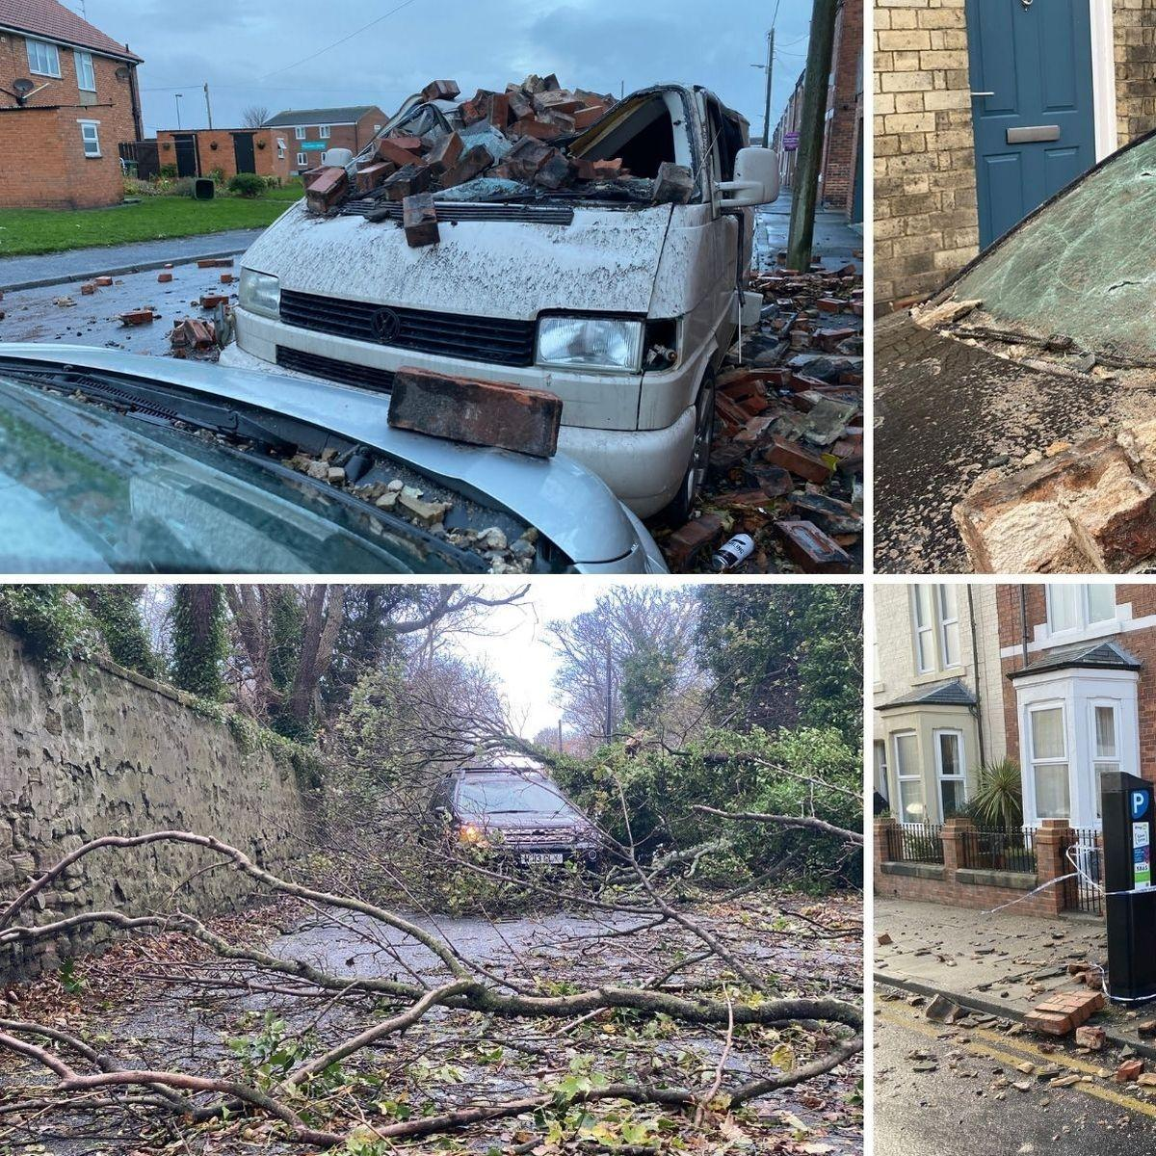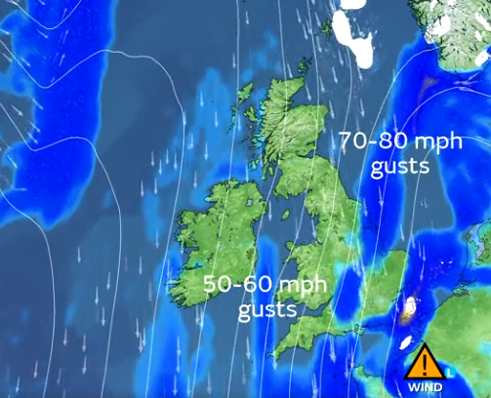
 | The damage of Storm Arwen has caused buildings to fall on cars or vans like in this picture.  To stay warm I had to get as many blankets and keep them on me since I couldn't put the fire on since I have an electric fire.” Jane Brown said.  Alex Deakin, who is a well known meteorologist, stated that the storm will intensify over a few days. He also said the storm would drive south and strong winds, rain and snow from the north. Gusts from up to 70-80 mph and winds would continue through the night. There were several weather warnings and travel disruption.  Callum, a local school boy,was left homeless. On Friday, his roof blew off because of the strong wind. Callum stated that “I was terrified that my family and I had to stay in a hotel and I do not know if I will be home for christmas.”  A spokesperson from the northern power grid stated that “the power would be retired to all homes as soon as possible.” They also stated that “in future they will be prepared in case it happens again.” | The gusts are really strong, some of the strongest winds in the UK.  Julie Smith who is a single mother with 3 kids and she said she was really struggling. Her house was as cold as outside. She and her Family had to wear winter coats, gloves, scarfs and hats. Julie said “I felt like a horrible mother not being able to provide my children with hot food or a warm house”.

