Gateshead Daily
Storm Arwen Strikes
Storm Arwen Strikes The U.K  Leaving Destruction Behind  by Austin  This week a terrible storm happened across the U.K but mainly Scotland and the North East of England. This storm was named Storm Arwen. It happened on the 26th and the 27th.  We have interviewed three people. Jane Brown a disabled woman that had no power during the storm, has said,”I thought I wasn't going to survive”. Callum Dent, a 10-year-old boy, has experienced something that has happened to him”I was so devastated I could not go home my roof flew off”. Julia Sharp had no power for her kids. She said”It made me feel desperate”.  The Met office has given a red wind warning. Storm Arwen has a wind speed of 75 mph so I recommend staying inside.  We are expecting some snow overnight but the main thing you should beware of is the strong gusts of wind. There should also be power cuts and damage to property.  In England, North East in  Northumberland 30,000 people had no power. Many people have been forced to leave their houses.  RAC breakdown spokesperson Simon Williams: high winds can seriously affect vehicles handling , so drivers need to make sure that strong gusts don’t take by surprise. Alex Deakin, a meteorologist from the Met office has said,”Strong winds to the U.K”.  The people that have been affected by the storm are now doing: Callum Dent is now  living in a lower-end accommodation. repairs are underway. Jane Brown’s power has come back on but she is now campaigning for better infrastructure in the north east. | 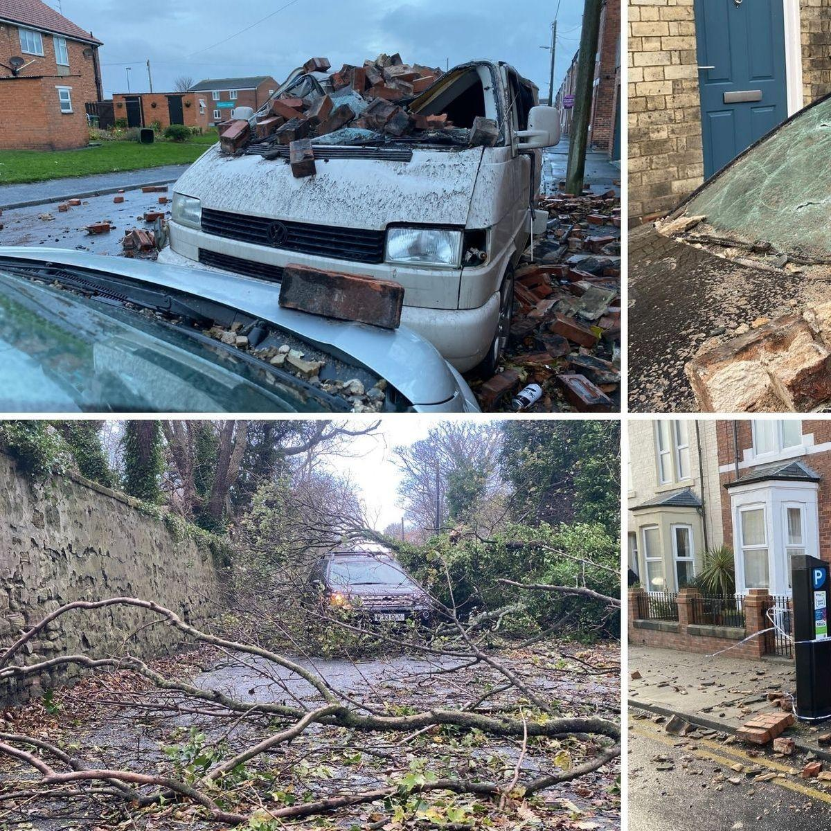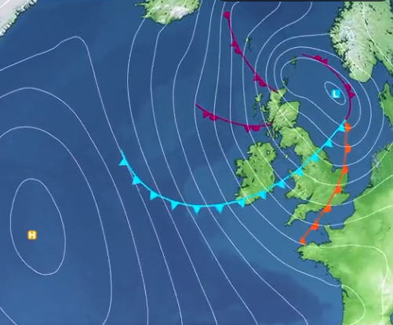
Simon Williams: high winds can seriously affect vehicles handling , so drivers need to make sure that strong gusts don’t take by surprise. Alex Deakin, a meteorologist from the Met office has said,”Strong winds to the U.K”.

The people that have been affected by the storm are now doing: Callum Dent is now
living in a lower-end accommodation. repairs are underway. Jane Brown’s power has come back on but she is now campaigning for better infrastructure in the north east.

The Northern Power Grid has apologised for the delay to turn on the power.They have admitted to saying the power is back on wedensday

