Windy Nook News
Storm Arwen Strikes
It leaves British houses in pieces  by Blake  This week Storm Arwen hit England and Scotland . It hit the region with very high winds and severe weather. The north east of England was most affected. It destroyed people's homes . Arwen occurred on the 26th and 27th of November .  There was an amber wind warning across the U.K. As Well there was a red wind warning for the North East and East Scotland. The wind was over 75mph. There were very strong winds and extremely cold weather . Arwen has disrupted travels and infrastructure.  In the north east there were over 30,000 homes destroyed and without any power . Many people like Harry Cole were forced to leave their homes because of the damage. People’s cars have been destroyed by many tiles and bricks that have come loose and fell over. Some people's caravans have toppled over into people's gardens . Bins have fallen over | 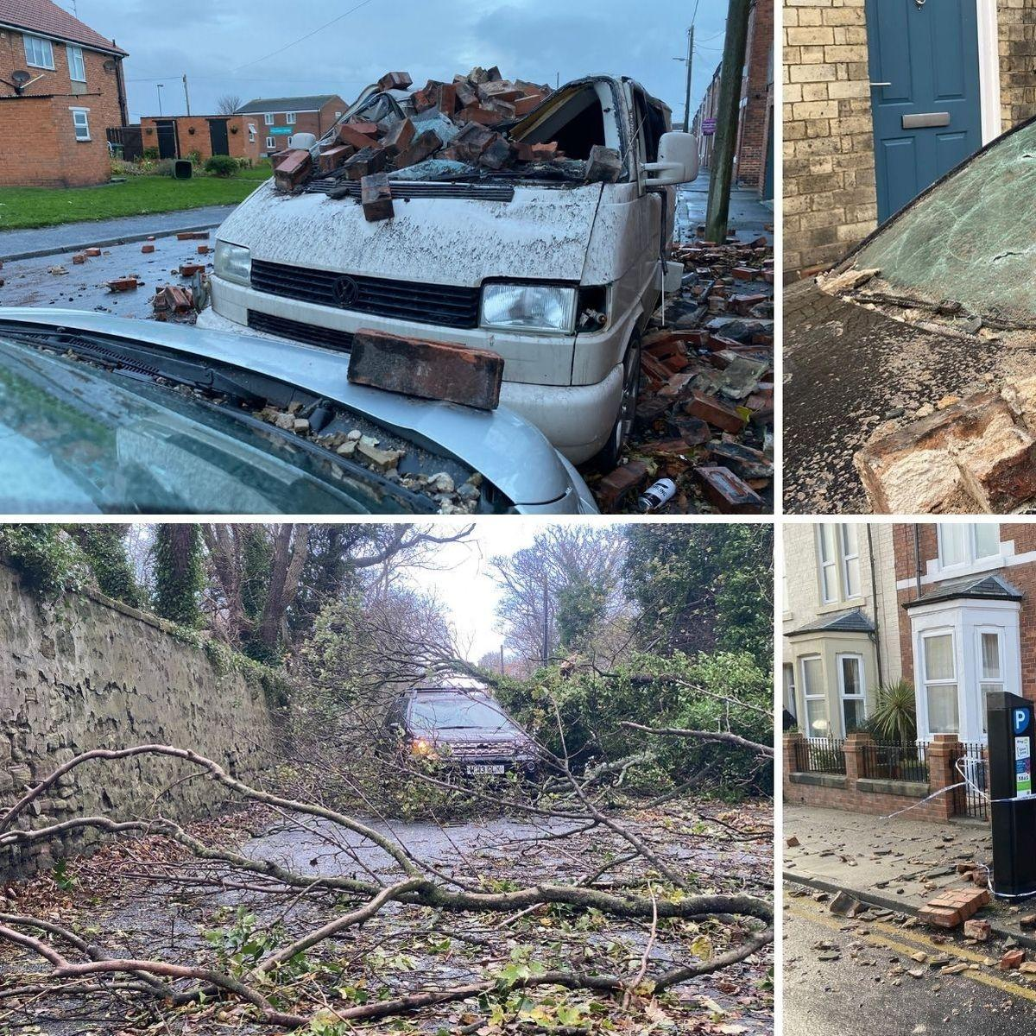  Some of the damage across the U.K.
 | and rubbish has scattered everywhere.  Experts warned people all over the U.K. about Arwen. Alex Deakin said Disruptive wins of over 75mph are forecasted. The low-pressure system will bring the worst of the storm on Friday to Saturday. Rac break down spokesperson Simon Williams said “High winds can seriously affect vehicle handling, so drivers need to make sure that strong gusts don’t take them by surprise.”  2 weeks after Arwen, Harry Is still without a home but repairs are underway. Happily, Jane’s power has came back on but she is campaigning for better infrastructure in the north east. People in the north east are demanding a better response from the goverment in the time of crisis.  Northern Power grid apologised for the delay in getting the power back on . They also said it will be Wednesday when all power will get back on. | Jane Brown, who was a disabled in Arwen, was without power for several days. She relies on power for a lot of things. “ I thought I wasn’t gonna make it because of how cold I was”.  Harry Cole, a 10 year old boy , who lost his roof in Storm Arwen, Is now living in an apartment in Durham with his family. Repairs or now under way on his house “I was devastated to not be able to stay at my house at christmas because of Storm Arwen.”  Julie Sharp, who was a single mother , had lost all of her power and heating . Every morning she got up with her kids and it was freezing down the stairs . Also  It was even harder for her because had to keep giving her kids jackets and blankets to try to keep them warm. “ It made me feel desperate.”

