The North’s News
Storm Arwen Strikes
Storm Arwen leaves 30,000 homes without power  by Callum  This week Storm Arwen hit the U.K. and left us with severe damage to homes, cars and trees. The MET office had declared a red weather warning as gusts of wind were over 98mph.  Storm Arwen “ One of the worst storms in decades” has forced people to leave their now unsafe houses due to flooding and other dangers. More than thousands of trees have fell over and some have fell on to peoples houses. | 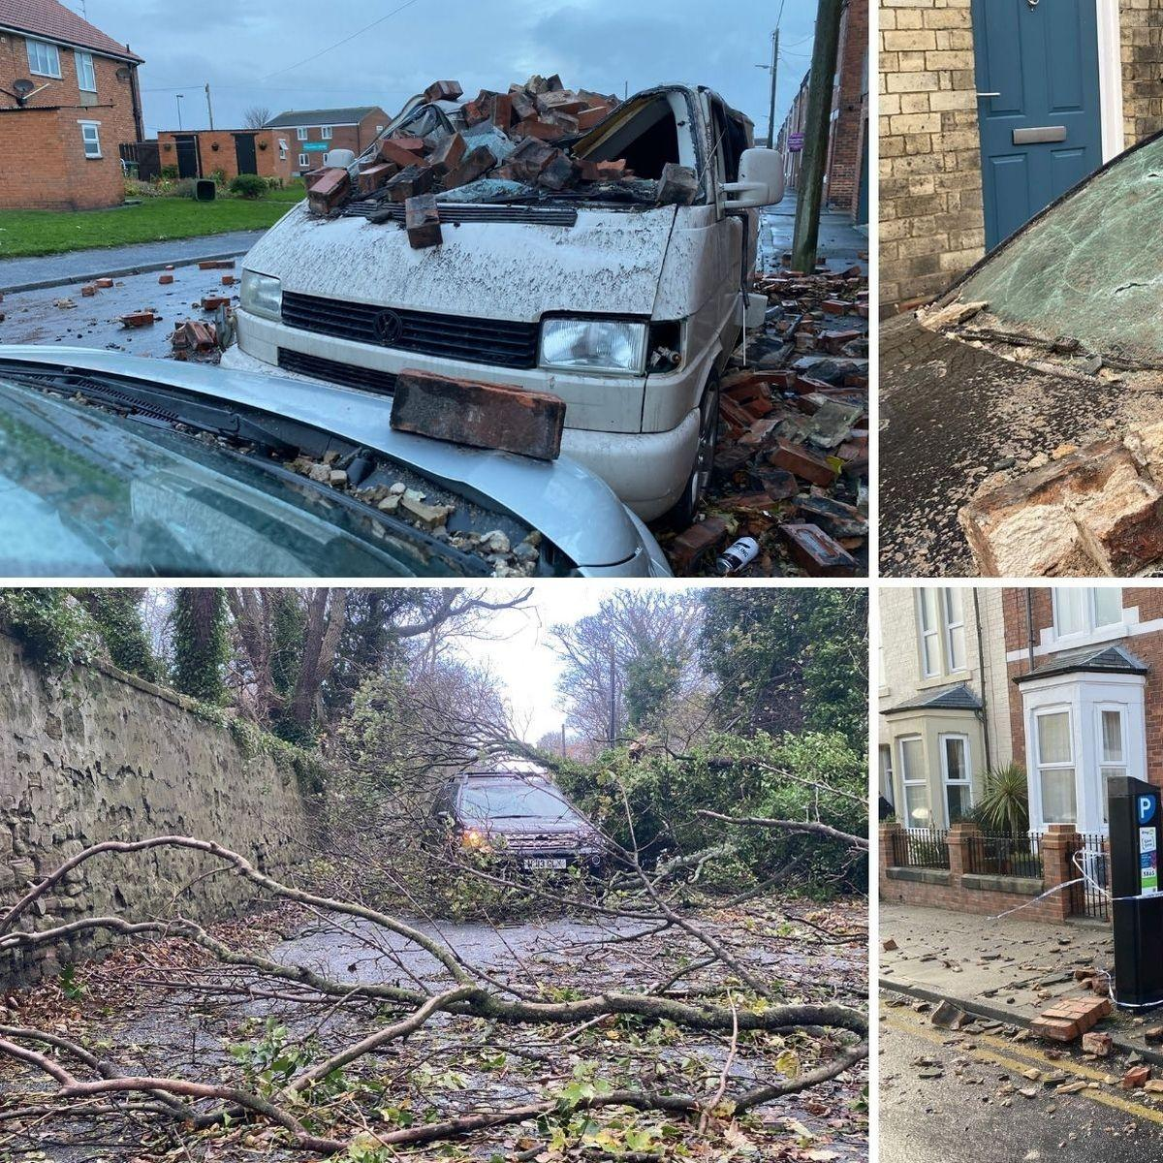  Houses and cars destroyed because of Storm Arwen
 | RAC expert and meteorologist Alex Deakin both warned the public about the dangers of this storm. Alex Deakin “Disruptive winds of over 75mph are forecast.The low pressure system will bring the worst of the storm.” RAC expert Simon Williams “Drivers need to be prepared for the strong gusts of winds so that they don’t take them by surprise.”  Luke James , a 10 year old boy,who is from Gateshead, has lost the roof of his family’s home. Luke James “I am devastated about not being able to spend Christmas in my own home.” Luke James is now temporarily living in an apartment in Durham. | Jane Brown, who is disabled, is so thankful to Northern power for getting her power back on. Jane relies on electricity for many things such as her wheelchair and heating but for the last several days she has gone without power and lay in bed wondering if she will ever get her power back. Jane Brown “ It was so cold for days on end, I didn’t think I was going to make it.”  Luke is still living in the apartment and Jane has got her power back but is trying to get Northumberland to protest for the government to focus on other cities and towns which aren’t London.

