Windy Nook News
Storm Arwen strikes the u.k.
30,000 people left without power and many homes severely damaged.  by ellie  Storm Arwen caused disaster in the UK. It brought high winds and severe weather to the whole of the country.  The worst hit areas were Scotland and the north-east of England. People in those areas suffered terrible damage to their homes on 26th - 27th November.  We spoke to Jane Brown, who lives in Eastgate, and is disabled. She relies on electricity for many vital aspects of her life. Gale force winds brought power lines down, therefore cutting off her electricity. She told us that she cannot manage without electricity. “I can’t cook or even make a hot drink. I live on my own, so I have no help”, | 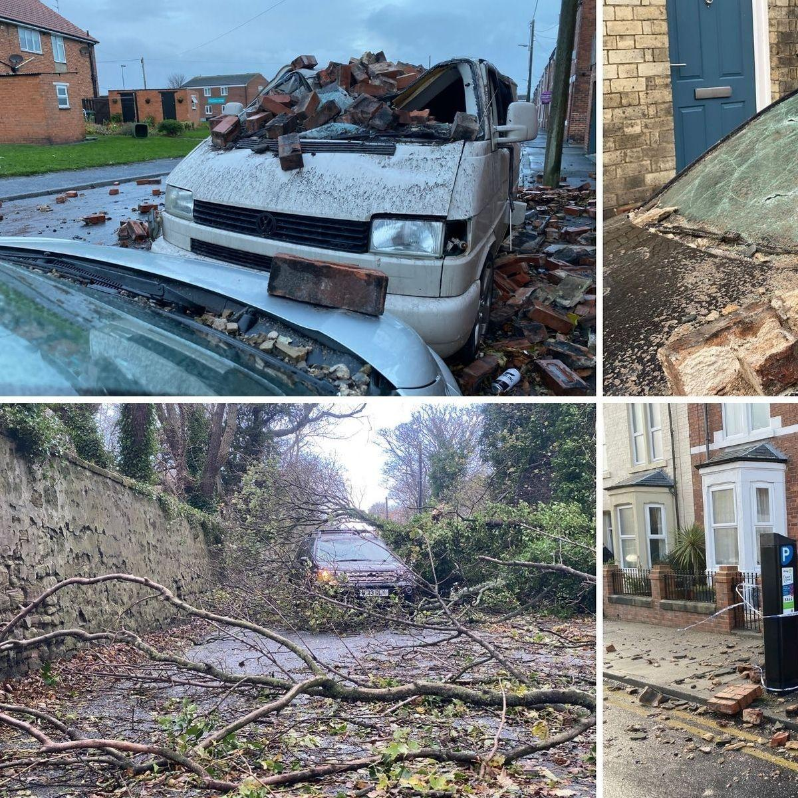A house collapsed on to a parked van.
 | The meteorologist Alex Deakin reported that the worst of the storm would be on Friday and Saturday with expected winds of over 75mph. Jane’s power is now restored, but she is campaigning for the North East to have a better infrastructure. People in the North East are demanding an urgent response from the Government in times of crisis.

