Weather News Weekly
Storm Arwen Stikes
Storm Arwen leaves 30,000 homes damaged and without power.  by Grace  This week, Storm Arwen was named and hit the region with high winds and severe weather across the U.K. People in the North East and Scotland have experienced the worst of the storm on 26th Friday leading into 27th Saturday.  Experts say that there will be yellow snow and wind warnings across the U.K but amber wind warnings are most likely to come. Gusts of wind have been reaching up to 75 to 80mph so experts recommend staying indoors until the storm passes over.  In Northumberland, winds started travelling at a shocking 98mph putting a red wind warning in place. Around this area, 30,000 houses had no heating or electricity for six days and people had to evacuate their homes because of the major damage. Lucinda Brown, a disabled woman, relies on electricity for many vital aspects of her life. She said “It was so cold, I thought I wouldn’t survive.” Lucinda was | 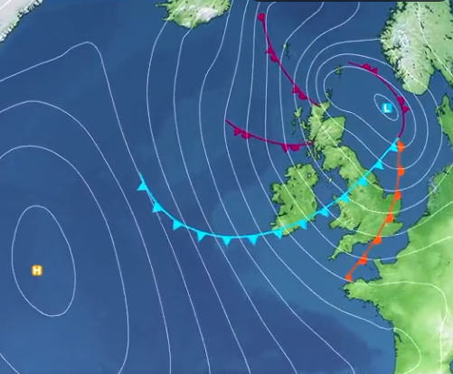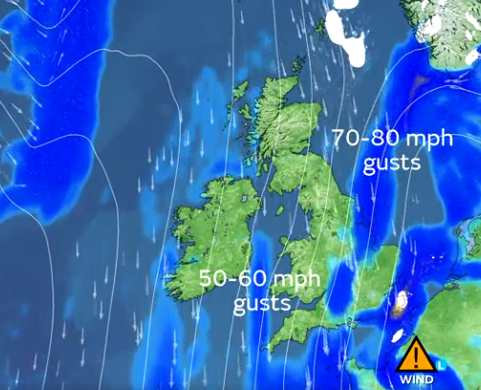 Amber to Red wind warnings
 | relieved to see that the electricity came back to Northumberland and now she is campaigning for the government to have a better response to the North East in times of a crisis.  Down in Gateshead, a lot of damage has been caused due to the storm. Lewis Macdonald, a 10-year-old boy, has had to leave his home due to his entire roof falling off. “I was devastated that I couldn’t spend Christmas morning at home to play with my toys,” says Lewis. Lewis has had to live in an apartment over Christmas and he is still not back in his own home, repairs are underway.  The storm has also affected a single mother. Julie Sharp has not been able to provide her children warmth and hot food due to the electricity cut. Julie said “It made me feel desperate.” | A lot of damage was caused including falling trees, falling walls and chimneys, crushed cars and falling roof tiles which can be a major threat.  RAC breakdown spokesman, Simon Williams, says “High winds and can  seriously affect vehicle handling so drivers need to make sure that strong gusts don’t take them by surprise.  Alex Deakin (meteorologist), MET office, said “Disruptive winds of over 75mph are forecast. Low pressure winds will bring the worst of the storm on Friday and Saturday.”  Northern Power Grid apologised for the delay in getting the power back but it would be Wednesday before the power is restored.

