Windy Nook News
Storm Arwin strikes u.k.!
Woman so cold not being able to stop thinking about death.  by Harvey  This Friday storm Arwin brought high speeds at 69mph across the whole of England. Power lines destroyed houses, collapsed bricks over cars and a couple of deaths. This disaster happened overnight till 26th and 27th 2021 causing a load of damage. A red warning sound telling everyone that there was a storm. The highest gust was 85mph bringing a severe lot of damage.  Thousands of houses without power and hundreds of felled trees. Jane Brown, a woman without power for three days as she explained that she couldn't cope, kept on thinking she wouldn't make it. She said “I was in bed freezing. I thought I wasn't going to make it because it was so cold without electricity. There was a red amber wind warning.  Another family that was affected was Jake Wilsonson, he says “I woke up and when I looked outside I was devastated when I had seen that my roof was in my neighbours garden”. It had been one of the most damaging storms in decades. Some people in Scotland didn't go to school due to the damage . The incredible amount of snow and rain had also affected houses and trees.  Over each night it was arranged by less than 5℃ being incredibly cold especially for the people who didn't have power. Telling people to be careful while driving because they could crash by the wind and snow.  Businesses and restaurants have shut down because of the storm rubbish across the streets. People have to struggle through all the coldness without heating because they have no power, no tinned foods or no lights.  But however the weather is getting better and power is coming back so it is getting normal again which is good. Everyone is relieved for power to come back but still have to get through the horrificness of being cold. | 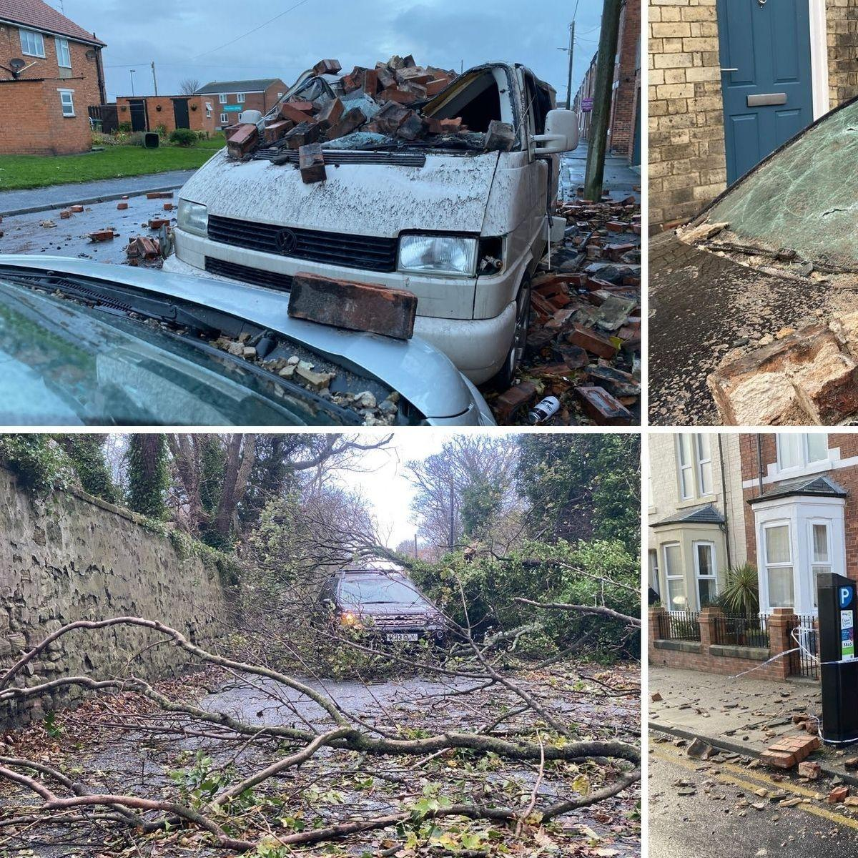
 | The impact on the north east is the most affected spot with bricks over cars and houses that have collapsed.

