North East News
Storm Arwen visits UK!
United Kingdom’s homes are destroyed due to a new storm.  By Isla  On the 26th and 27th of November, an unexpected storm occurred in the UK leaving many families and people with destroyed belongings. Mostly the North East of England and the east of Scotland.  We have interviewed some people who have been affected by the shocking storm. The first person is a desperate woman, Jane Brown, who had no heating, electricity nor happiness for three days. Unfortunately, Jane has many electric things that she uses for her health and to get around easier. Even though her electricity went of, which was already extremely bad, she was freezing cold and spent them 3 lonely days in bed. She said “It was bitterly cold and she didn’t know whether she would survive!”  The next person we interviewed was a young student, Tom, who shockingly lost his roof roof due to Arwen. He is only ten and was unable to spend Christmas in his own home! Whilst his roof is getting repaired, him and his devastated family have had to live elsewhere for over a month now. He said “Spending Christmas in a different place was extremely hard.”  Within a few days, the UK was notified that there was an amber wind warning and Storm Arwen was on his way! The wind was blowing around at 75 mph and even more later in the storm. For both Friday and Saturday, there was going to be horrendously bad weather, disrupting anyone’s travelling plans. | 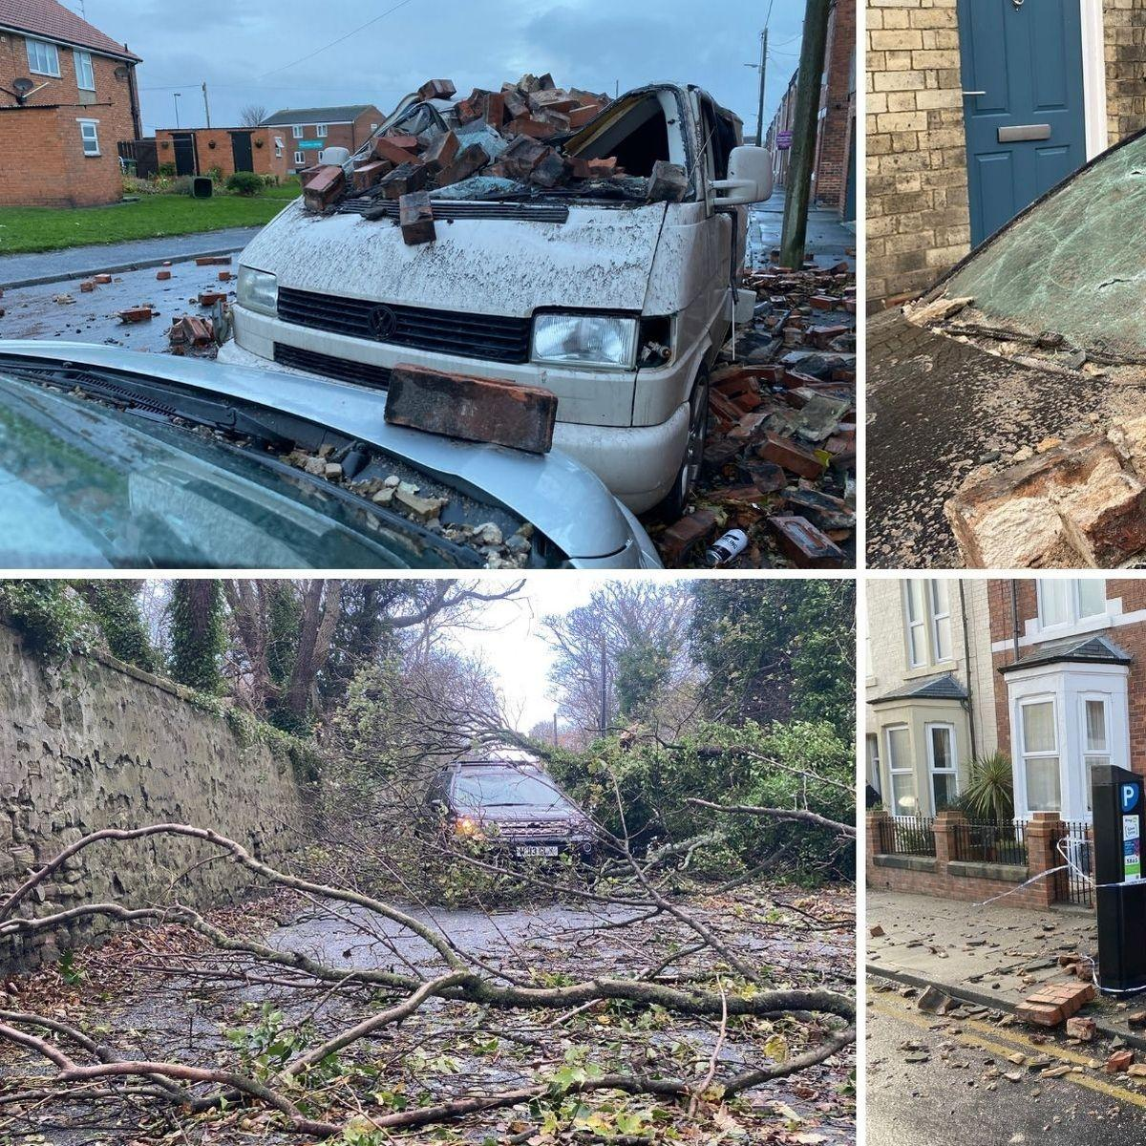Some of the horrid tragedies that people experienced during the storm!
 | In the North East, 9,000 people’s houses had no power for 8 days! There was lots of damage to people’s homes. As well as that, many people were forced to leave because of how much damage; Storm Arwen was powerful enough to break people’s sheds, pull their artificial grass up and even blow their furniture to the outside of their house! Not only did Arwen cause lots of trouble with people’s things, it also made people very aggressive and tearful as it was unknown what was going to happen next!  Experts were very helpful during all of the upset as they informed everyone about the weather and informed people to be careful. RAC spokesperson, Simon WIlliams, let the public know that high winds can seriously affect vehicle handling, so drivers need to make sure that strong gusts do not take them by surprise! A met office meteorologist named Alex Deakin warned people about the surprising 75 mph winds and the low pressure system will get the worst of the storm over with on Friday and the early hours of Saturday. That was quite inaccurate though because victims are still struggling with the aftermath of the storm right now!  Now, Tom is still not back in his family home but enjoying having a big bedroom as his was very small. He has actually quite happy the storm pulled his roof off because he thinks getting his room decorated is exciting. That proves, you can still look at the positive in things even without a roof. Repairs are underway at his home.. | Jane is relieved that her heating is back on, her electric is working and she isn’t feeling as anxious anymore. I think in the future, these two victims might get more prepared if they see any signs of a storm coming. For the North of England, Jane is campaigning for better infrastructure and people in the North East are demanding a better response from the government as they feel ignored.  “You hear of trees falling in London but what about the trees in Northumberland?” Jane said.  When the North East are in a crisis, people in the South probably have no clue! The Northern power grid apologised for the delay on getting the public’s power to work and they admitted themselves it would be Wednesday before some people’s power got turned back on.  Overall, Storm Arwen was horrible and the North East and South of Scotland should have had much more help during the incident. Lots of people did look out for the victims such as soldiers, roofers and and repairers though. However, the government need to think about how they have made some of their community feel.If a storm ever occurs, be prepared and get all of your supplies before because we do not want to repeat the ridiculous events that happened in Storm Arwen!

