Windy Nook News
STORM ARWEN strikes the uk
storm arwen  joseph leonard  when strom arwen stuck it severely injured lots of people and some peoples houses and cars and garages fell down all the trees and wind and rain it even killed some people put out their power and damaged some peoples cars some brick fell off the roof and killed some people and fell on vans buses and cars and people it caused a tragedy my grandmas chimney pot blew off and her areal blew off as well because the wind is so strong it even blows off people's roofs the news reporters have interviewed some people that were involved in storm arwen some peoples trampolines got blown away even some  people got blown away  they closed bridges over the river because the wins where that strong it could damage or pull off some of the bridges it was really bad for homeless people because hey could freeze to death or get blown way and killed them hopefully we stay safe and warm in our houses stay safe. | 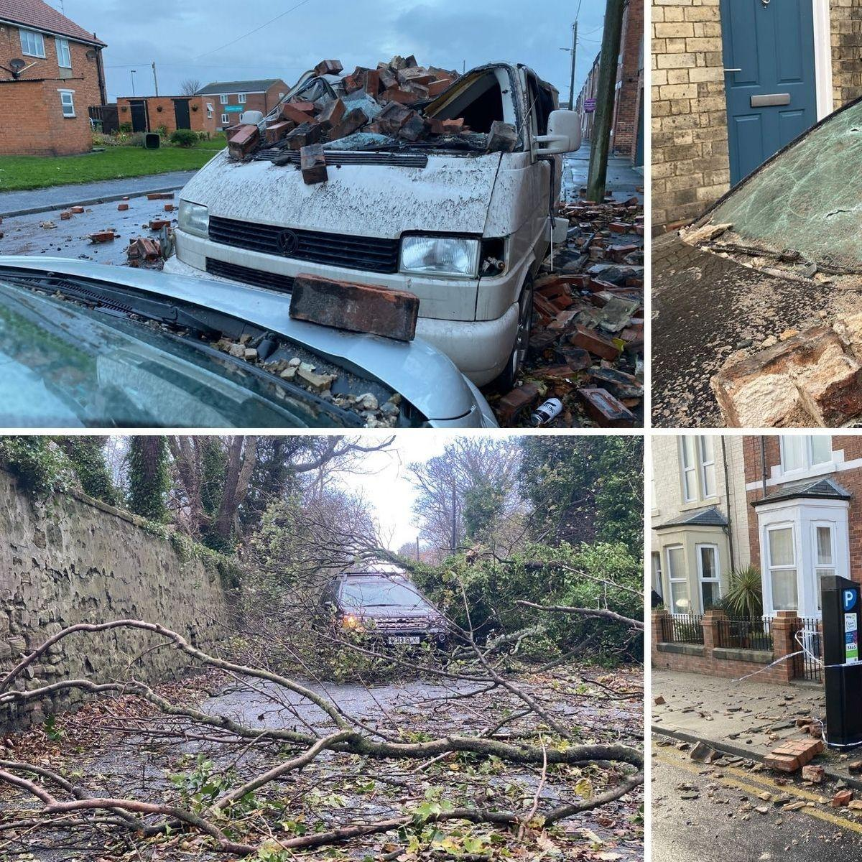
 | some people got interviewed and peoples cars got blown down hills into the big muddy wet grass destroyed some people were out at night and got blown over and couldn't get back up and blown away and even killed or knocked out by something being blown by the wind or pass out of shock and coldness and the wind i so bad some people couldn't even breath and some people died because their entire house fell down my grandmas chimney pot blew off and her areal blew off too that night was a tragedy

