Windy Nook News
Storm Arwen Batters The UK
Wind Causes Chaos In  Morpeth  by Larkin  This week residents, emergency services and power companies were in a terrible storm on Friday 25th of November late afternoon, through to Saturday 26th of November. There was destruction covering the UK, trees fell down and roufs fell off. Some people have to stay in a hotel because their homes were damaged in the storm.  Amber wind warning for the northeast ,  Scotland and England. Roads were disrupted by the storm because trees fell on the road so you could not drive on them. Storm Arwen has been named and is forecasted to bring a period of very strong winds are way. 5,000 people are still left without power in Northumberland 8 days after the storm hit. The army is deployed to spread community spirit. Some residents are even left hungry.  Jane Brown, a disabled woman who was without power for several days, is a resident from Morpeth. Jane Brown said “It was so bitterly cold I thought I wasn’t going to survive”. She said it was very hard for me to live without electricity because I was in bed for 99%of the time, since it was difficult for me to get in my wheelchair I couldn't move around as much. It was hard having no lights but I used candles so I could see.They didn't really help though,because they were very dim. I was very, very scared because I physically thought I was going to die because all of my food was rotting. Some of my food was outside so that it could stay fresh and some was also in my room since | 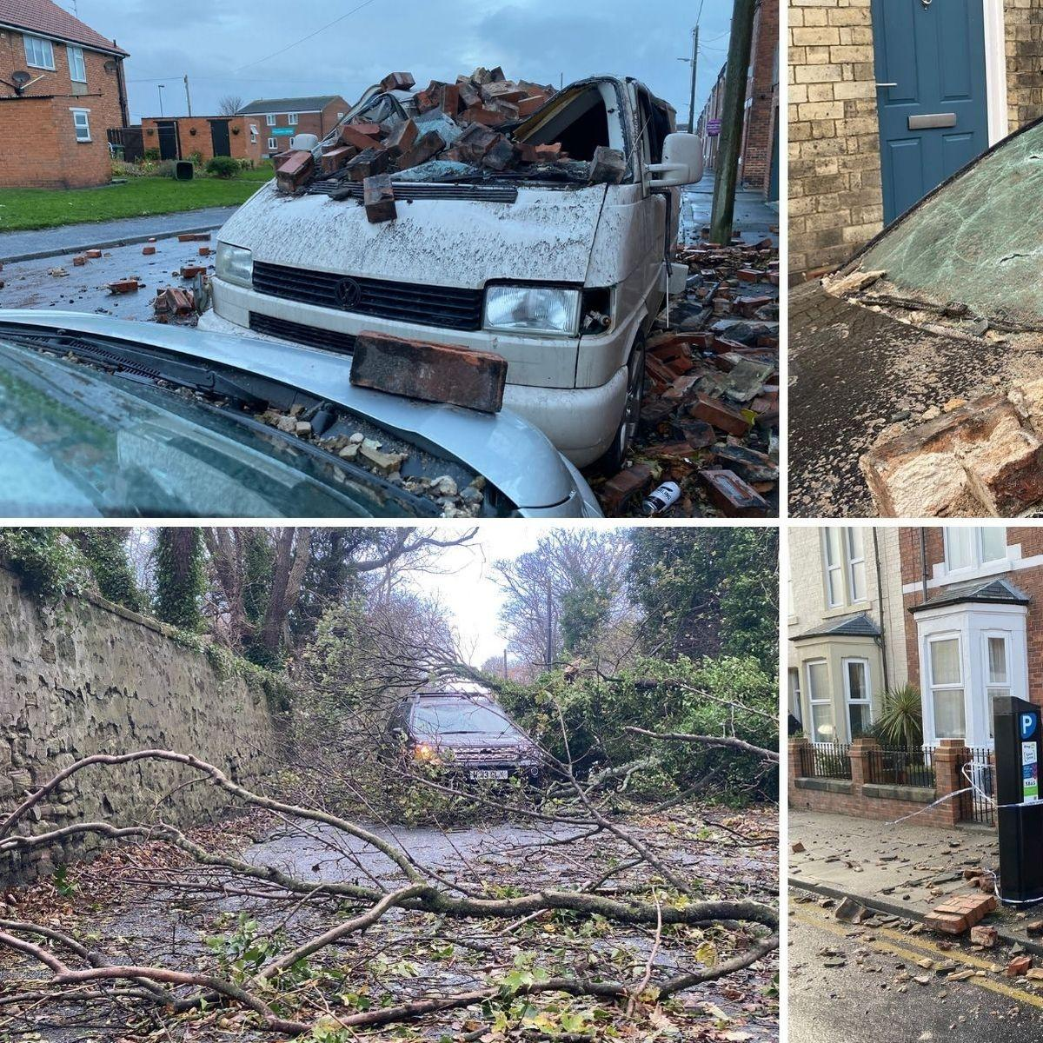  Trees falling on top of cars and blocking roads.
it was very cold.

Alex Deakin, who is a meteorologist, informed everyone that the storm was coming.Alex Dekin, who is a well-known meteorologist, stated that a really bad storm is coming on 25th of November with very bad winds at 70-80 mph. Travel disruptions have been happening and the weather will settle down on Saturday.

A man from the Northern Power company set out to go and fix a power cable in Northumberland.

