Windy Nook News
Storm Arwen
Sub-headline  By Oliver  This week storm Arwen has caused destruction throughout the UK. Earlier on this week we could see that it was shown as an amber storm warning and said to bring different gusts of winds varying from 50 - 80 mph. This meant that you could not travel long distances for safety reasons. Lots of residents from the UK have been terribly affected ranging from losing your bins to getting your garage blown away. Some people have had their whole house lose power for over 8 days and since it is the middle of a very cold winter they have had to dress for the outdoors when they just want to get some sleep. It has been incredibly hard for these people, fortunately different power companies around them have said they will have power on soon and that no one should start to panic too much. Some people are not happy with this and have said that their areas that they live in have been forgotten about and it is a disgrace.  One Morpeth resident, Jane Brown, has been interviewed and said that she did not think she would even survive. Jane is a 45 year old woman who lives in Morpeth, Northumberland. Jane is independent and disabled she has to have her electric wheelchair to get to places but since she had no power it was extremely hard to get from one place to another. When interviewed she said “I didn’t think I would ever survive because it was so bitterly cold”. Julie Smith is a single who has to be able to access power so her children can stay warm and entertained but since she is one of the power cut victims she can not do them things and she has to have a fire on at all times to stay warm and cook food. She said that “It made me feel very desperate”. Callum, a local school boy, Whose family household's roof has unfortunately has blown away in the storm this young boy comments that “I really just want to be home”.  A famous weatherman Alex Deakin, was the first weatherman to talk about Storm Arwen and said that there will be very strong winds and that it is extremely dangerous so everyone | 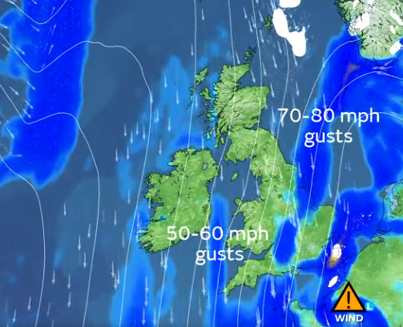  should stay inside at all times and never go out unless it is absolutely necessary. He also said that the gusts of winds will be worse at the top part of the UK than the bottom part but it will still be terrible.  Northern power said that they are trying their best to get the power back on for the north so people like Jane Brown, Callum and Julie can get back to their normal lives.

