Windy Nook News
storm arwen
Wind causes chaos in Morpeth.  by paige  Friday a late afternoon there was a storm on saturday morning it blew away the uk. .The event happened in Nationwide,North east ,Northumberland and Morpeth.It happened at 25.11.21 and it destruction and the land.The emergency came out and said they don't know how long the power will take.8 days after people still without power.Storm arwen has been named and is forecast to bring a period of very strong winds.Amber warning was in England and north east in Scotland.Some local resident now have to live in a hotels because of how bad the storm is.5000 that's a lot because of this storm well a lot of people are living in hotels.Some people are angry because they been forgotten.  I interviewed Jane Brown,Alex Deakins and the spokesperson from Northumberland powers.  I asked her what it was like without power and she said it was bad without power because she said (I was cold I thought i wouldn't survive).She said she just stays in her bed with a lot of blankets and a warm drink.We ask her is she scared and Jane Brown said yes I am scared because I was alone and in London the lights would just come on.  Callum, is a local school boy, was left homeless because his roof came off by the storm.(I was devastated to not be able to spend Christmas with my family) he told the windy nook news.  Jane Brown got her power back on and the Spokesperson did it but it took 8 days.They also started that the future will have generators and power lines with a lot of power lines in the ground.  Juile smith was back with heating and electricity again she was so glad she had her electricity before christmas had came up. | 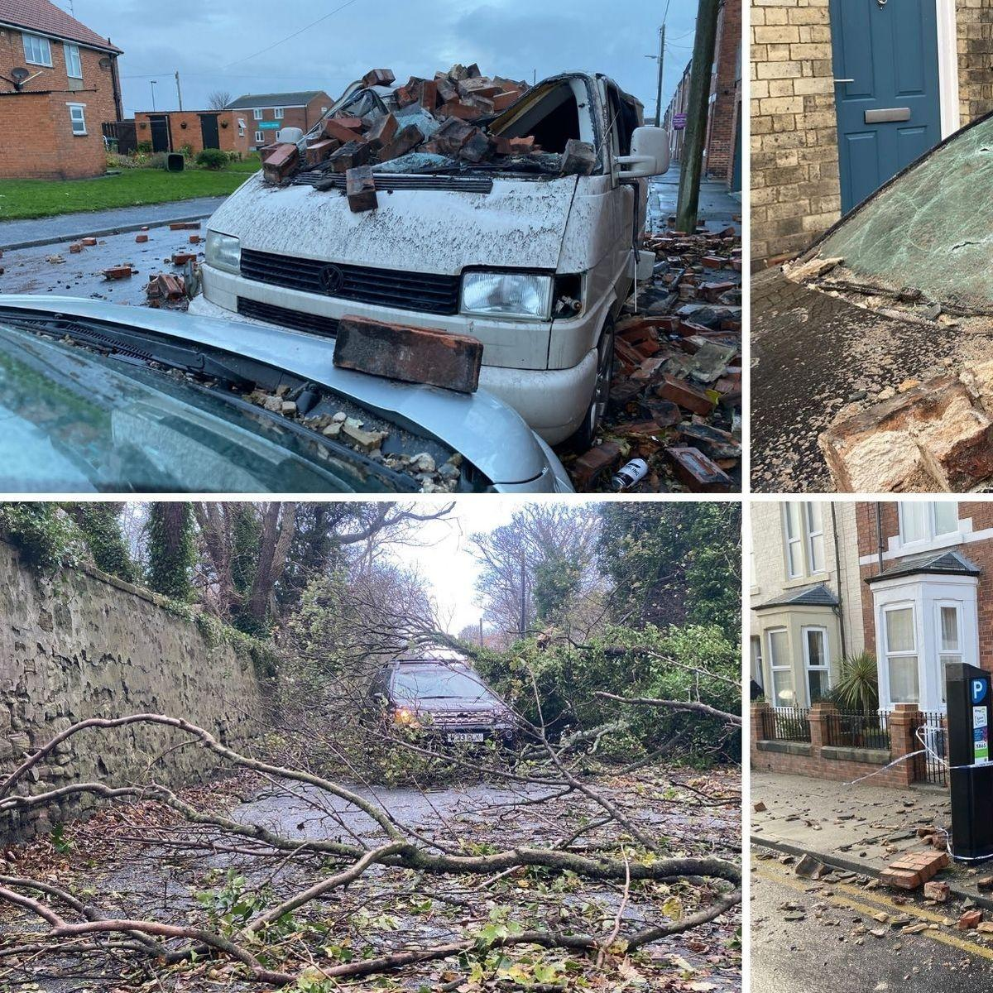
This is dangerous some cars can’t get past because of the trees and some cars have got rocks on the cars.This tree is blocking the car from maybe getting to work or going home but this storm is very bad.
This car has got its home fall onto his van.Some cars have glass broken because of how strong the wind was.

