Windy Nook Chippy
Storm Arwen striking the UK
Storm Arwen  BY Thomas  This week Storm Arwen is bringing down the roofs across most of the UK and particularly the North East. The emergency services have been deployed all around the UK. 5000 residents are feeling forgotten because of the Northern Power company taking forever to fix the power to their houses.  Jane Brown, who is disabled, is a resident in Morpeth who lives alone and relies on electricity a lot. As a result of the storm her power went out she even said that it was so cold she thought she wouldn't survive. Callum, a 10 year old school boy was left homeless after the storm took off his family home roof” I was devastated that I couldn't spend Christmas at home and play with my toys” . Julie Smith , a single mother who was without heating and power while trying to care for her young children. She mentioned that it made her feel desperate.  Alex Deakin is a well known meteorologist he has advised for people to stay inside your house. He has advised to stay in because of the strong winds and twigs flying and the rain is hitting fast. | 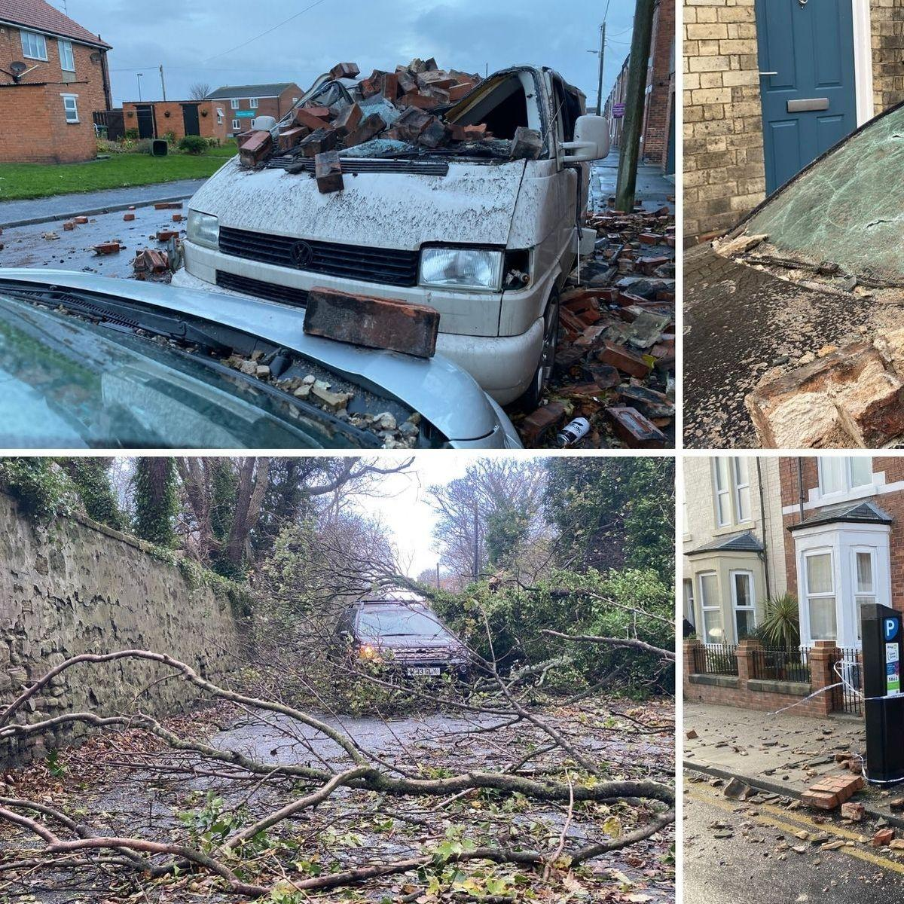  A van that was crushed by a lot of bricks from a garage.  Now Jane Brown has power again . Callum has moved back to his house and Julie Smith has heating and electricity. From now on Jane , Callum and Julie will be a lot more cautios from now on and get northern power to make the houses better.

