Windy Nook News
ARWEN ARRIVES IN THE UK‼️
The Tragedy!  by Tom . 25p  This week, we have had reports of the destruction of Storm Arwen. This has affected the lives of countless people and multiple communities. Many people will not make it past this storm and many are injured. This morning I went to an estate that was wrecked. Particularly the North-East. This tragedy took place on the 26/27th of November 2021. We got the following pictures earlier today.  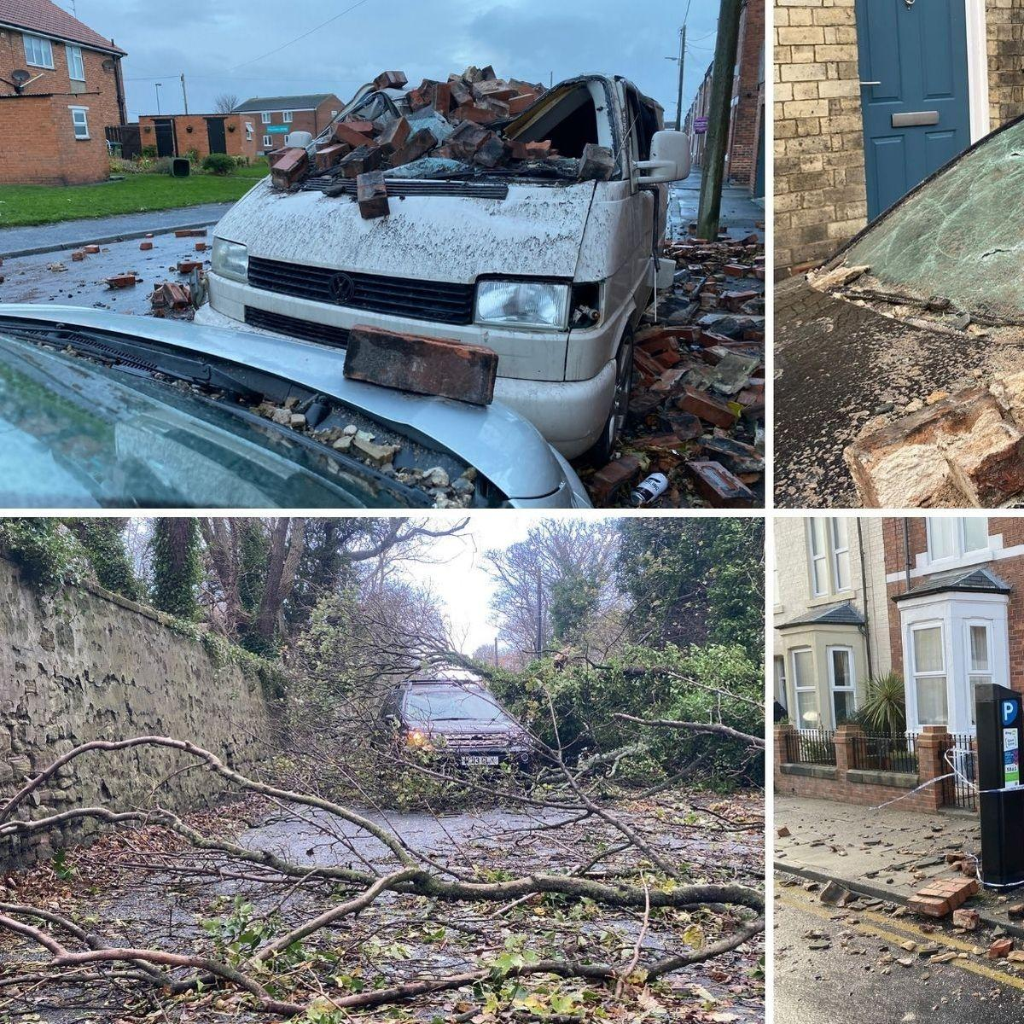 | Weather forecast for Windy Nook this week:  Monday 17th: 🌧  Tuesday 18th:🌪⚠️ 🔴 warning.  Wednesday 19th:❄️  Thursday 20th:☃️  Friday 21st:🌥  Saturday 22nd:🌤  Sunday 23rd:🌈☀️
 | These photos show the total destruction of the country. We have had some eyewitnesses including Jane Brown who is an individual person who lives on her own and relies on electricity that powers her wheelchair and her communication with her family. The following are questions that we asked and her answer.  How much has this storm impacted your life?  Well I try to live a normal life although it is more challenging. I feel isolated in my own home with my electric wheelchair that is unable to move due to a consistent flat battery.  How did you feel?  I thought I wouldn’t make it out of my bed alive when I heard my roof tiles rattling and objects hitting my house.  How important is electricity to you?  My life depends on electricity because nearly everything I do depends on it. Getting out of bed, moving and going downstairs are essential things I can’t do now in my daily life.  People like Jane are in trouble. Without electricity, people are cold and unable to eat warm comforting food. People need to stay at hotels and friends houses which puts them at high risk of catching covid-19 until their homes are good enough to live in. A co-worker was at the scene of a demolished street and told me this.  The streets are atrocious and are an utter mess. Garages were knocked down, fences came out, trees were in half, road signs were everywhere on the floor and even bricks came out of houses onto the road. The roads were getting cleared from the debris of the estate.  This is Tom Stevens reporting from a very Windy Nook. | TODAYS OTHER NEWS!  Boris Johnson forgets to say ”Mister Speaker” p5  The Queen trips on the edge of the balcony p6  Newcastle beats Sunderland 10-0 p7  Man Bites Dog p8  LOTTERY RESULTS 11th  1️⃣ 2️⃣ 3️⃣ 4️⃣ 5️⃣ 6️⃣  bonus ball  7️⃣

