A comparison between Newcastle and Palermo
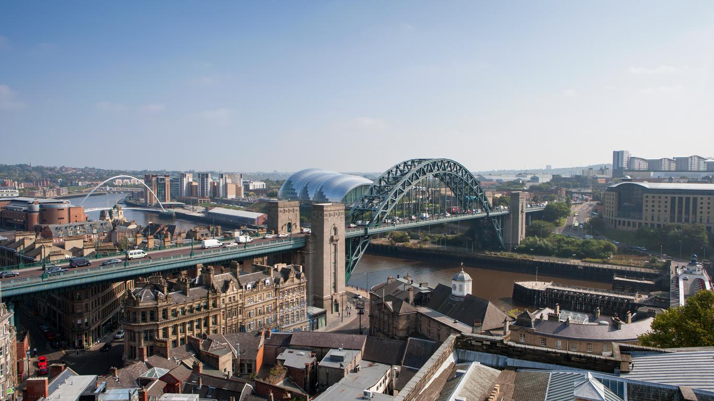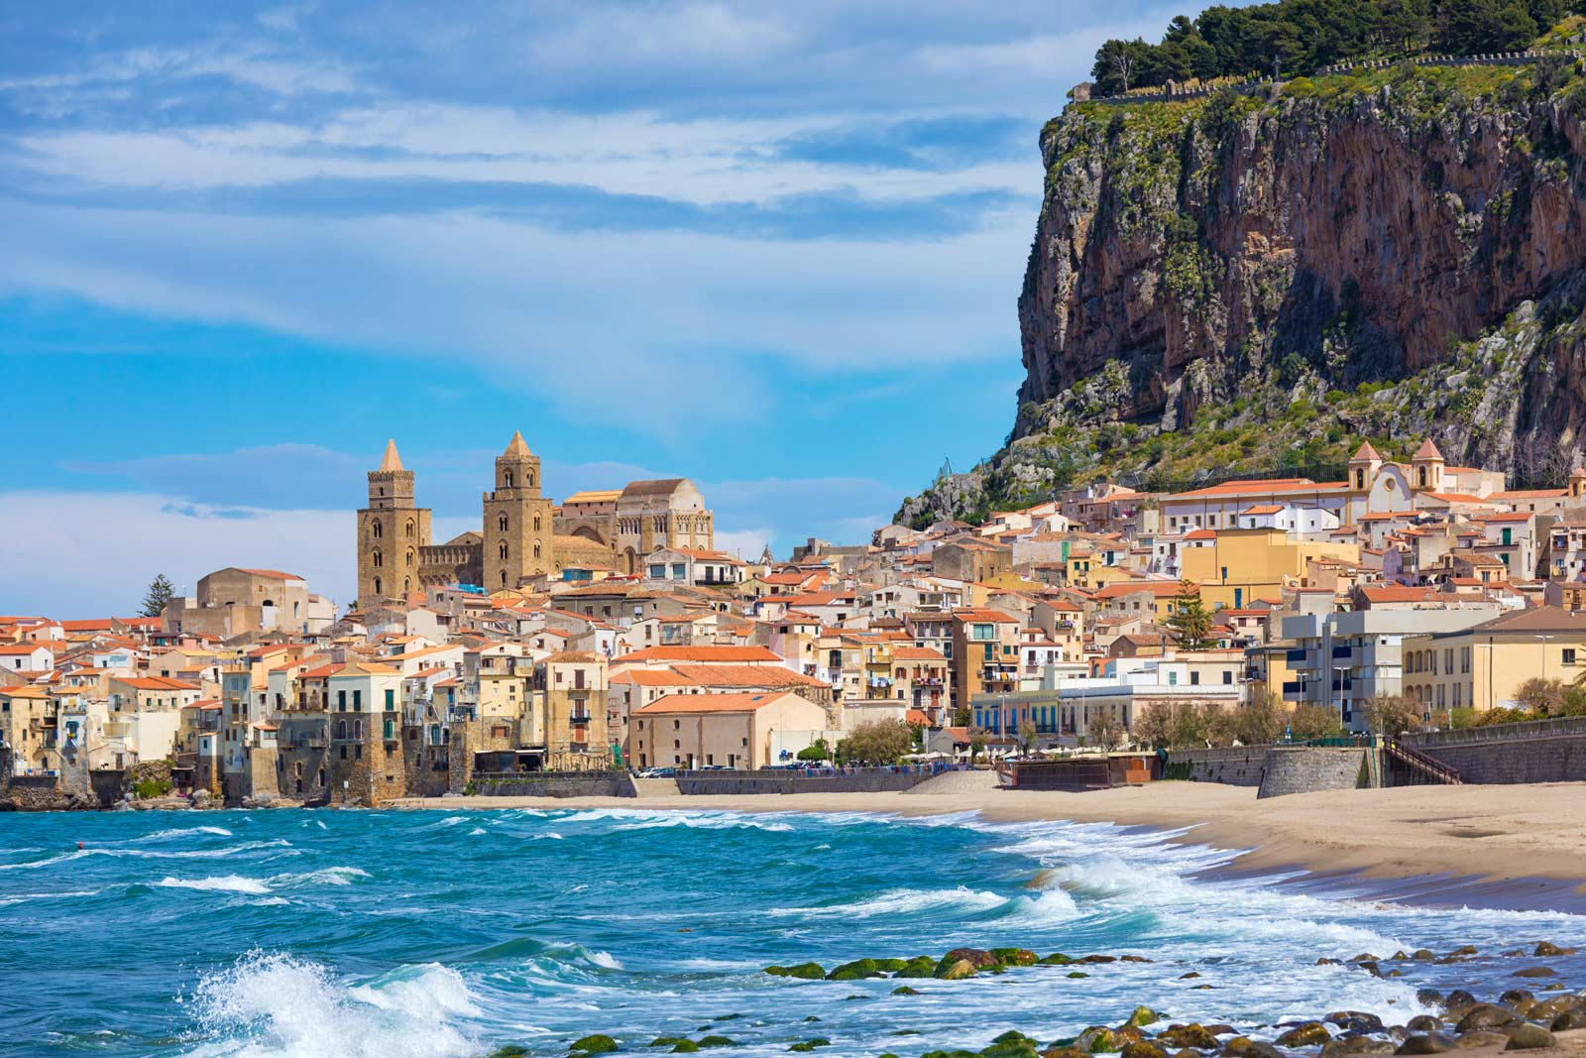
This report will compare the differences and similarities between Newcastle-Upon-Tyne (England) and Palermo (Sicily).

Climate
Newcastle experiences a temperate climate whereas Palermo has Mediterranean climate. Both places experience cooler winters and hotter summers. Palermo’s average temperatures are higher compared to Newcastle. The hottest months in Newcastle are July and August. In Palermo, it is hot all year round. Newcastle-Upon-Tyne Has rainfall all year round. However Palermo has high rainfall from October to February.

Land use and buildings
Both Palermo and Newcastle-Upon Tyne are popular tourist destinations with high rise buildings, castles and a Quayside. In Palermo, it is very similar to Newcastle because they both have football stadiums and many restaurants. Palermo also has beaches, theatres, museums and palaces. Another similarity is that they both have castles, cathedrals and ports.

Transport
In Newcastle-Upon-Tyne, there is many bus stations, electric scooters and train stations such as the Metro. Also, they have a Newcastle International Airport. The colour of the electric scooters are orange and black and you have to rent them to ride one. In Palermo, they also have airports, bus stations and train stations. One of the train stations are called Palermo Brancaccio.

Population and tourism
When you visit Newcastle, you have amazing views, brilliant nightlife’s and loads of pubs. Also you could go and watch concerts at St James Park or you could watch Newcastle play against another team and you could go to a restaurant and eat at one of the best ones. In Palermo, they have one of the best beaches and coasts, palaces, cathedrals, theatres and museums.

In summary, Palermo and Newcastle are both European urban cities which experience similarities in historical buildings and land use and differences in climate.

