A comparison between Newcastle and Palermo
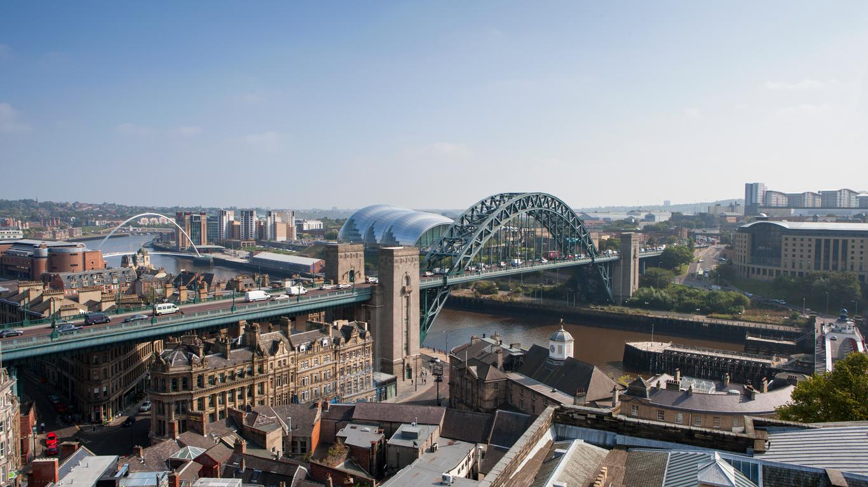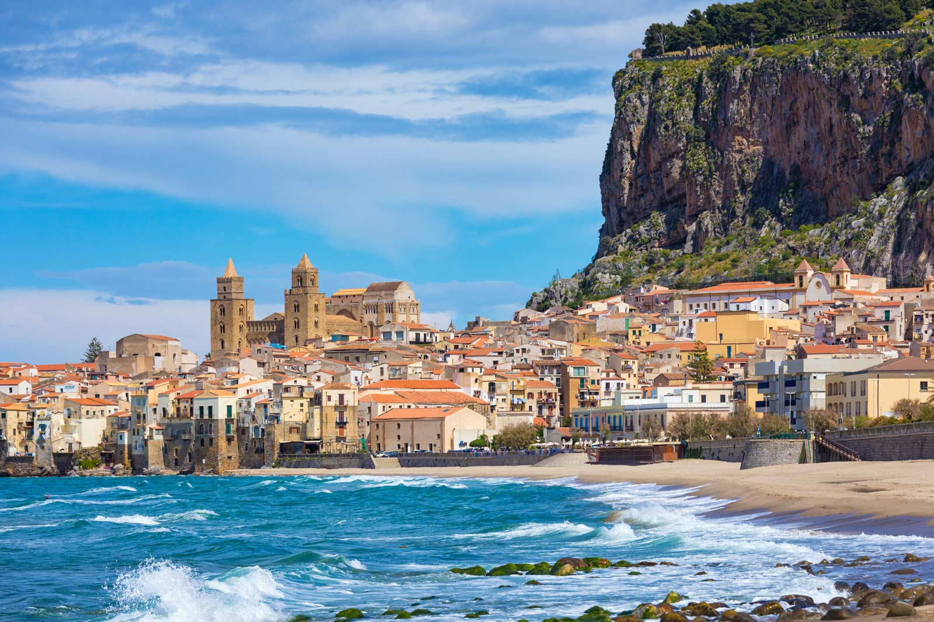

Climate
Newcastle experiences a Seasonal climate whereas Palermo has a Mediterranean climate. Both places experience cold winters and hot summers. Palermo’s average temperatures are 25.5 degrees compared to 15.5 in Newcastle. Palermo also experiences slightly more rainfall than Newcastle.

Land use and buildings
In Palermo, some of the most popular land use and buildings are cathedrals and churches along with palaces, hotels, courtyards and flats. Meanwhile in Newcastle, there are many schools, Universities and a College followed by hospitals, bars, shops and theatres.

Transport
Some of the transport in Newcastle includes, Cars, Buses, Taxis, the metro train and much more! Palermo’s transport is Trams, trains, coaches, buses and cars. There seems to be less transport in Palermo than in Newcastle.

Population and tourism
The population in Palermo is 850,000 whereas in Newcastle its 818,000 this means that more people live in Palermo than Newcastle. The tourism in Newcastle is galleries, theatres, shops, sport stadiums, historic landmarks, museums, sage and more. In Palermo tourism is, port, holiday, religious visits, palaces, theatre, heritage and tons more!

Conclusion Paragraph
As you can see, there are many differences and similarities between Palermo and Newcastle. Differences include, Palermo is hotter and has more rainfall compared to Newcastle, there is better transport in Newcastle than Palermo. Similarities are they both have hot summers and cold winters with rainfall all year round. Another Similarity is they both have similar vehicles, examples are they both have buses and taxis. In conclusion, Palermo and Newcastle are very different but also share similarities.

