A comparison between Newcastle and Palermo
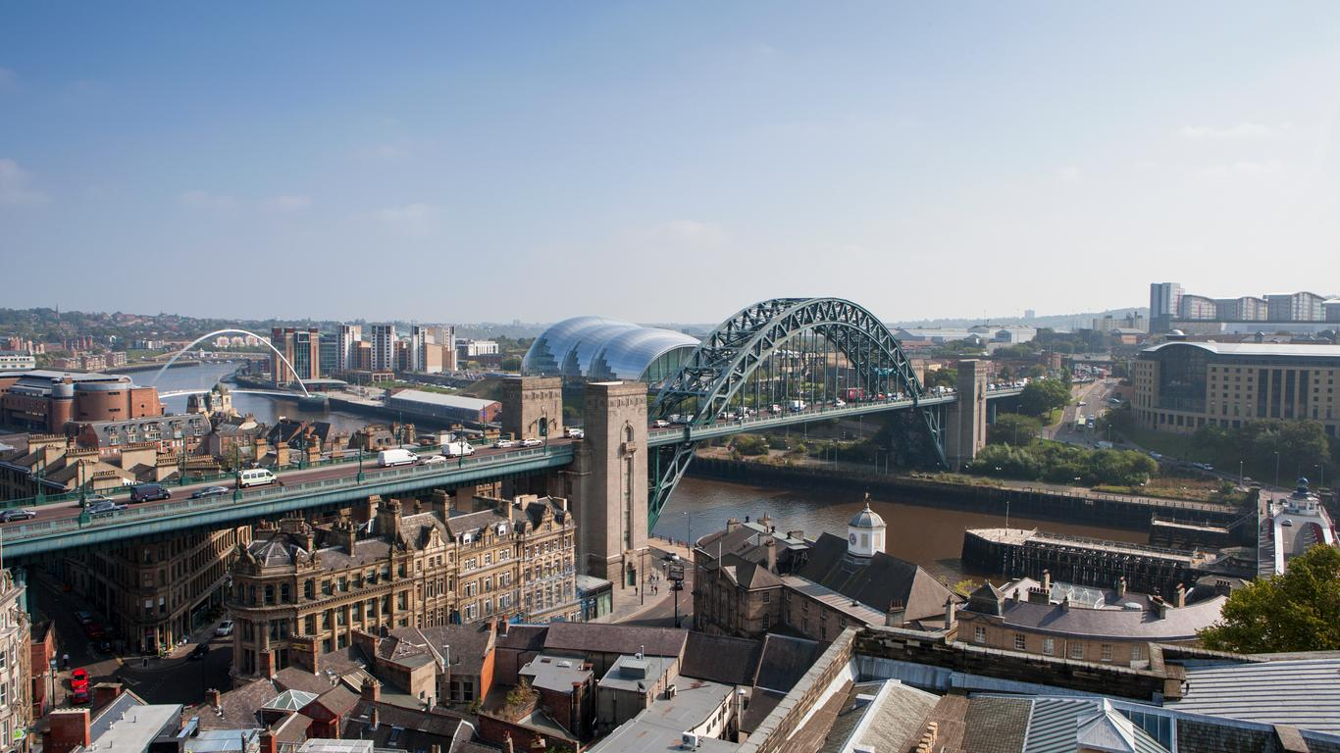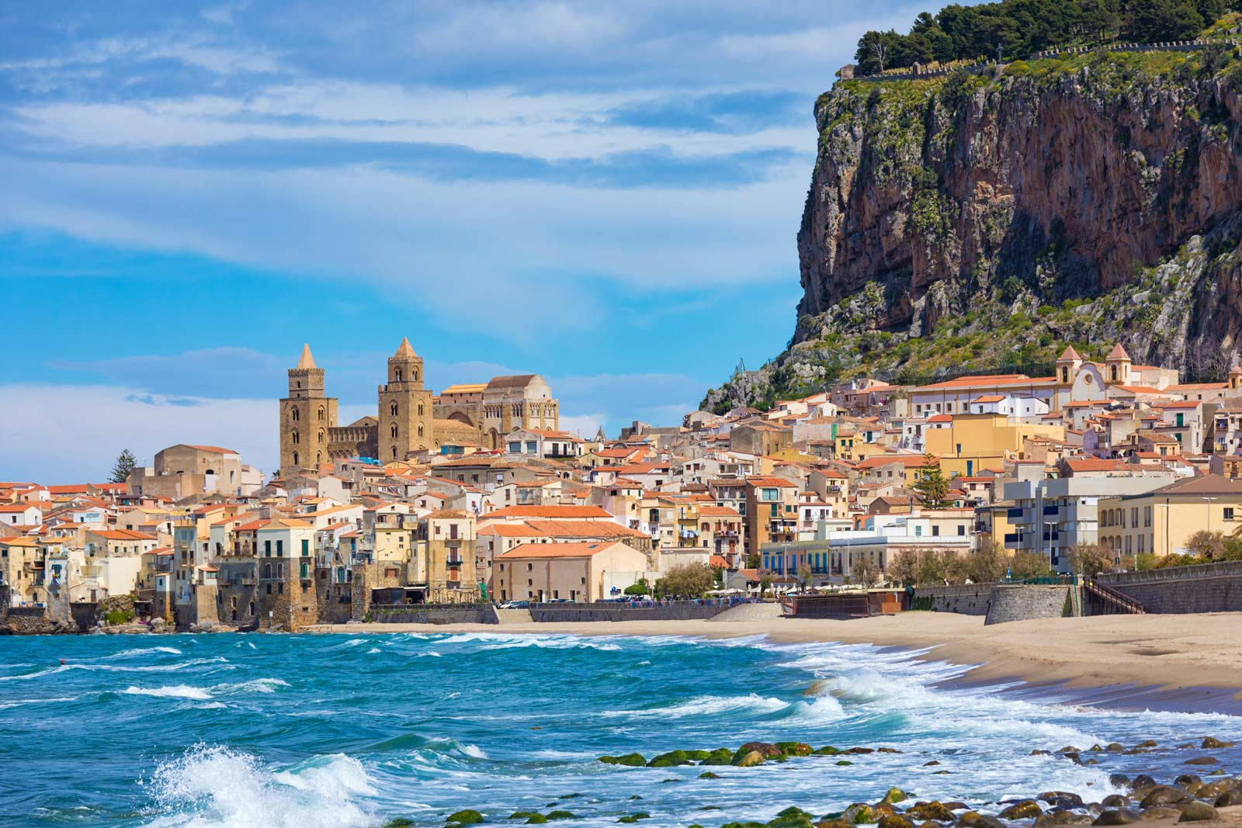

This will be a comparison text between Newcastle and Palermo. It will be focusing on the temperature, climate, buildings, transport, population and popularity.

Climate
Newcastle experiences a temperate climate whereas Palermo has a Mediterranean climate. Both places experience cold and mild winters and hot summers. Palermo’s average temperatures are 26 degrees compared to 16 degrees in Newcastle.

Land use and buildings
In Newcastle we use the land for restaurants, cafes, offices and sport stadiums whereas in Palermo they use the land for small streets, a port and hotels. Palermo also has much more greenery than Newcastle.

Transport
In Newcastle the transportation works quite well since the trains and buses run every fifteen minutes or fewer. We also have E scooters and taxis whereas the transportation in Palermo is supposedly quite bad (but I wouldn't know since I’ve never been there.) They have taxis and buses just like Newcastle but it is said to be quite bad.

Population and tourism
The population of Newcastle is 818,000 (rounded) as opposed to 850,000 in Palermo (also rounded.) People come to Newcastle for events in St James’s park and the night life. On average the number of people that fly to Newcastle is 84,000 holiday trips yearly. People usually come to Palermo for a holiday or religious purposes like visiting the cathedrals. On average the number of people that visit Palermo for holidays is 10,000 yearly.

Newcastle is very different to Palermo since Palermo has a lot of holiday arrivals in 10,000 but Newcastle only average 84,000. Also, Newcastle is very different to Palermo since Newcastle has a stadium but Palermo doesn't. Although the things that are similar are they both have over 800,000 in population. They also both have a train system and an airport so they both have a plane system. In conclusion, Newcastle and Palermo can have some similarities but they will always be very, very different.

