A comparison between Newcastle and Palermo
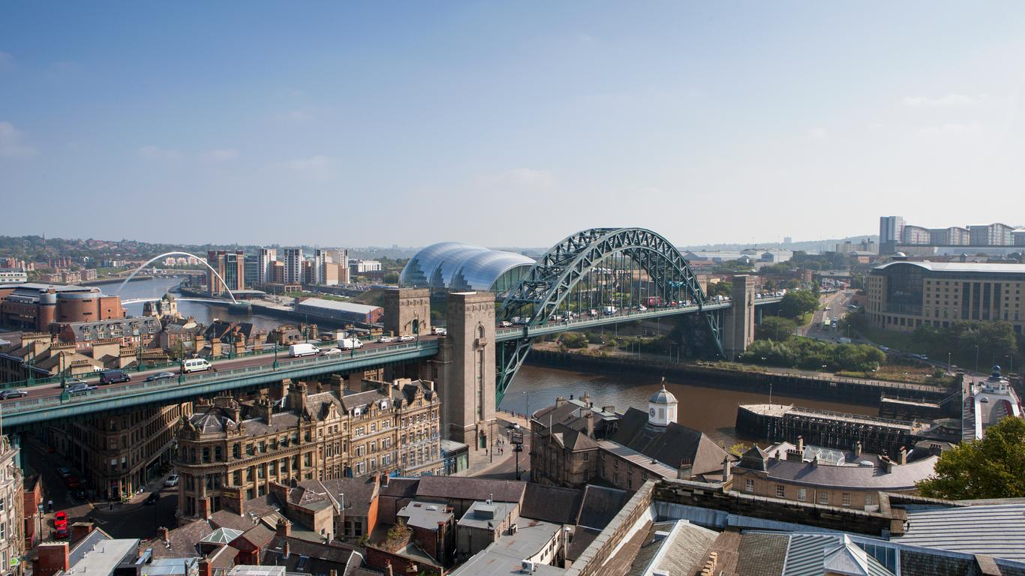
This text is about the differences and comparison between the city of Newcastle, UK and Palermo, Italy. This will include: the climate, Land use and building, Transport and Population and tourism.

Climate
Newcastle experiences a temperate climate whereas Palermo has a Mediterranean climate. Both places experience mild cold winters and mildly warm summers. Palermo’s average temperatures are 24 degrees compared to 13 degrees in Newcastle.

Land use and buildings
Whilst Newcastle has more houses, flats and urban areas, Palermo has more resorts/holiday homes (because of the weather there).Palermo, which is a very hot place, has more beaches compared to Newcastle -which has the quayside-.In Newcastle one of the most popular places to visit is St James’ park, which is where Newcastle United’s football team play. However, some of the most popular places to visit in Palermo are:shops, restaurants and some famous buildings.

Transport
In Newcastle, most people get around the town/city by using cars, metros and taxis. whilst Palermo use boats, buses and airports. This may be because Newcastle have way more roads and Palermo have very limited transport and vehicles. An average taxi in Newcastle costs up to at least £10 or a bit more depending on the route your taking or how far away the journey is. But on the other hand, a taxi in Palermo can cost up to 35 euros depending on what time of day it is. So even if the journey is 5 minutes away you still have to pay up to 35 euros if it is a certain time of day.

Population and tourism
Whilst Palermo is known for its holiday resorts, culture, restaurant food and beaches, Newcastle is known for its city, historic areas, the sage and tyne bridge.
Although most people think of holidays as warm places, Newcastle is also a holiday some people go on. This is because of the nightlife, shops and city.

